# Chapter 1 Introduction to User Portraits

## What is a user portrait

User Profile (Some also call it: User Portrait or User Persona )

Concept in one sentence: User information labeling ( Tag , Label )

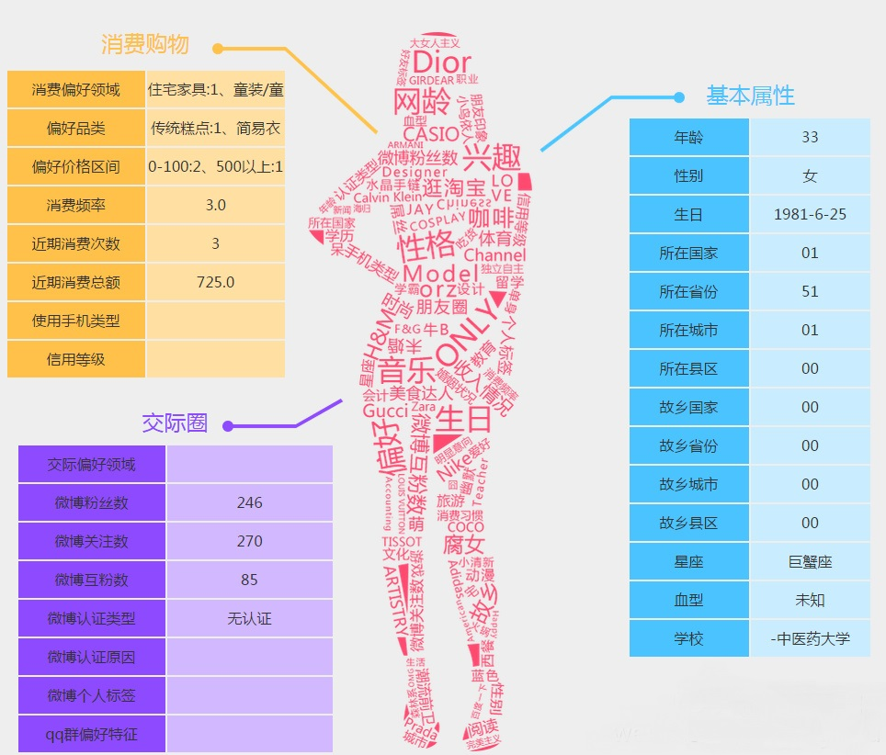

Through the collection of users' social attributes, consumption habits, preferences and other dimensions of data, and then characterize the characteristics of users or products, and these characteristics are analyzed and statistics, mining potential value information, so as to abstract the overall picture of user information .

## 1.2 Positioning and application

### 1.2.1 Positioning

## 1.3 User Tags

### 1.3.1 Label classification

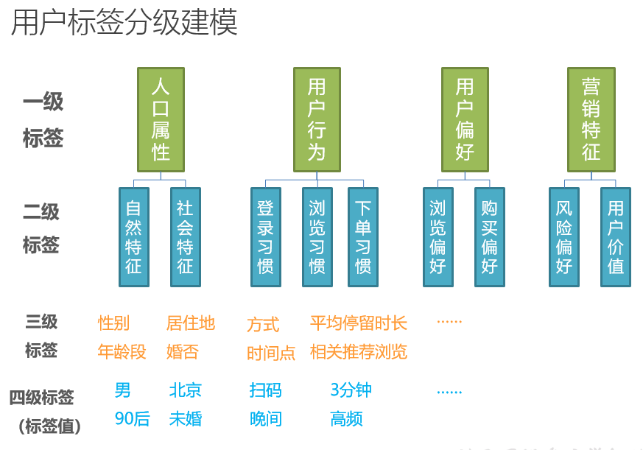

The entire classification generally has several levels: label classification, label, and label value .

For example: demographic attributes, social attributes, ordering habits, etc. all belong to label classification .

Gender, age group, and place of residence are all labels .

Male, born in the 1990s , and Beijing are all label values.

### 1.3.2 Tag classification

* **Statistics Tags**

Directly extracted labels are also called **factual labels** (objective facts).

For example: gender, age, last login time, average monthly consumption.

Has a very general and clear definition and is the most common label.

* **Rule Class Tags**

Need to customize rules. ( Subjective qualitative)

For example: high-value users, opinion leaders, electronics enthusiasts, and scalpers.

Operations, product, and business personnel are required to design rules and definitions that are suitable for their own business characteristics. Often, the same label has different rules in different companies.

* **Mining class labels**

Generally, the label predicted by **machine learning algorithms is also called the predicted class label** .

For example: predicting gender, predicting age, and potential lost users.

It is usually difficult to obtain a label based on a certain rule. **Machine learning is required to obtain a model algorithm** through repeated iterations of the system's existing data, and then obtain the label based on the algorithm.

The development cycle is long, the difficulty is high, and the accuracy cannot be guaranteed. However, it is often the most valuable label because the data obtained from the data sometimes reflects the real situation better than fixed rules.

# Chapter 2: Mian1 (Hand-drawn) User Portrait Architecture



## 2.1 Platform Functions and Technical Architecture

Function: Currently only the first level menu: tag management; process task management; task progress; user grouping

Provide visualization pages to define tags and the rules for tag generation, and even directly provide visualization development pages.

Provides a backend scheduling system to extract calculations from the data warehouse based on the rules defined by the tags.

The calculated user portrait tags are also managed by the platform, and users are divided into different groups through the combination of tags, providing support for other business systems.

**Technical realization:**

**The user portrait system** is essentially an internal management system that facilitates the user portrait development team to build tag management tasks based on standard web application technology.

**Vue.js** is responsible for the front-end page.

**Springboot** Responsible for the backend application, the data is stored in the MySQL database, **and** the related technical framework also includes MySQL Plus and **StringTask** .

The spark program task needs to be submitted to **Y arn** , **the SparkLauncher plug-in is also used** .

## 2.2 Image processing flow

**The portrait processing process** mainly **calculates labels based on the labels and the rules of the entire process** , and reorganizes the data in the data warehouse.

Generally, statistical and rule-based labels can be written using **spark -sql** , while complex rule-based labels and mining labels can be written using **spark -core** and **spark -mllib** .

## 2.3 Application of portrait label data: user grouping

Grouping operations are provided, so you need to operate OLAP that supports ad hoc queries and operate on tags and groups.

According to actual needs, we generally choose an OLAP database with good performance and support for ad hoc queries . It is used to filter users by combining multiple conditions, such as **Clickhouse** or **Elasticsearch** . At the same time, K -V databases are also used for accurate query of users and groups, such as **Redis** , **Hbase** , and **Pika** .

## 2.4 Project teaching module

(1) Understand the design ideas of the user portrait system, as well as the design process and application of tags.

(2) Construction and use of user portrait management platform.

(3) Understand the database tables of the user portrait platform, including the meaning of all tables such as the label table, task table, and progress table.

(4) Use spark to develop operations such as label calculation, reorganization, and export to complete the business processing flow of label calculation.

(5) Use Clickhouse\ Redis to store portrait data and filter multiple tags.

(6) Learn to use Springboot, Mybatis and other frameworks to complete user grouping functions.

(7) Introduction to machine learning, using the algorithms in sparkmllib to develop mining class labels (optional).

# Chapter 3 Code Builds a User Portrait Management Platform

## 3.1 System Materials

(1) Platform main program code package (because it still needs debugging and development, it runs locally directly in IDE)

(2) **The s park remote submission service Jar package is placed on the server with Spark environment.**

(3) Management platform, My SQL table creation script

## 3.2 * Platform database design -7 tables and table structures

Entities: tags, tasks, tag-task mapping, task processing status, task tag rules; user grouping

Table names: tag information tag_info table, tag task tag_common_task table; task information task_info table, task processing task_process table, task tag rule task_tag_rule table, user group user_group table; file information file_info table.

Import the data script in the MySQL management tool navicat/sqlyog/command line .

## 3.3Build a user portrait management platform

### 3.3.1 Import the main program into the IDEA project

### 3.3.2 Modify the relevant configuration application.properties

### 3.3.3 Modify the hosts file of Windows - add mapping 127.0.0.1 userprofile.gmall.com

### 3.3.4 Start the portrait platform application

UserProfileManagerApplication in the execution project

### 3.3.5 Access the profile platform - path : http://userprofile.gmall.com ; the account and password are hard-coded in the front end when accessing

# Chapter 4 (mian2) Tag management function - In addition, there are process task management; task progress; user grouping functions; if you are talking about the backend, you need to talk about these.

User profiling starts with the management of tags, that is, defining and specifying rules .

## 4.1 Tag classification list

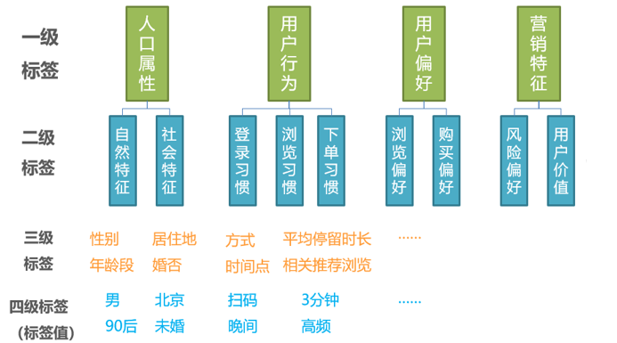

According to the previous planning of labels, we need to create labels in four levels here, where **the first and second levels are label categories , the third level is the main label , and the fourth level is the specific label value .**

## 4.2 Add tags

### 4.2.1 Add a new first-level tag

#### 1 ) Add a first-level tag

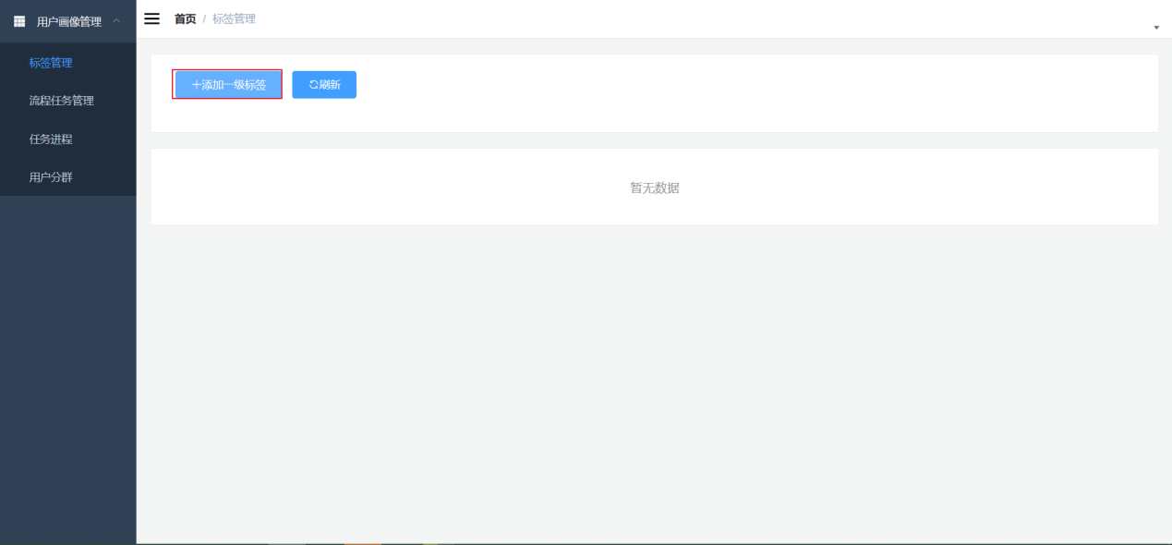

#### Enter tag information : code, name, type

**Fill in the field description on the page (product definition)**

|  |  |
| --- | --- |
| **Page Fields** | **illustrate** |
| **Label Encoding** | Fill in the code according to the rules (uppercase English) |
| **Tag Name** | Label Chinese name |
| **Tag Type** | **Level 1 and 2 selection categories, level 3 and 4 selections: value, floating point, text, date** |

#### 3) Examples

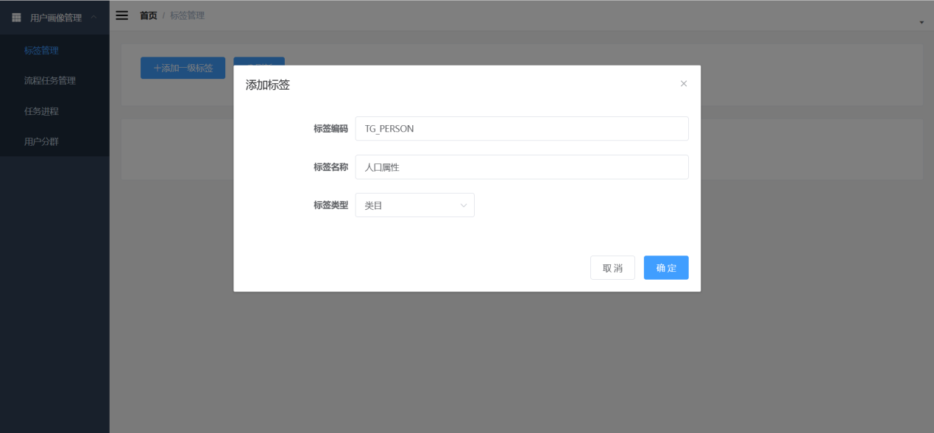

### 4.2.2Adding secondary tags

#### 1 ) Select Add Sub-Tag on the right side of the primary tag.

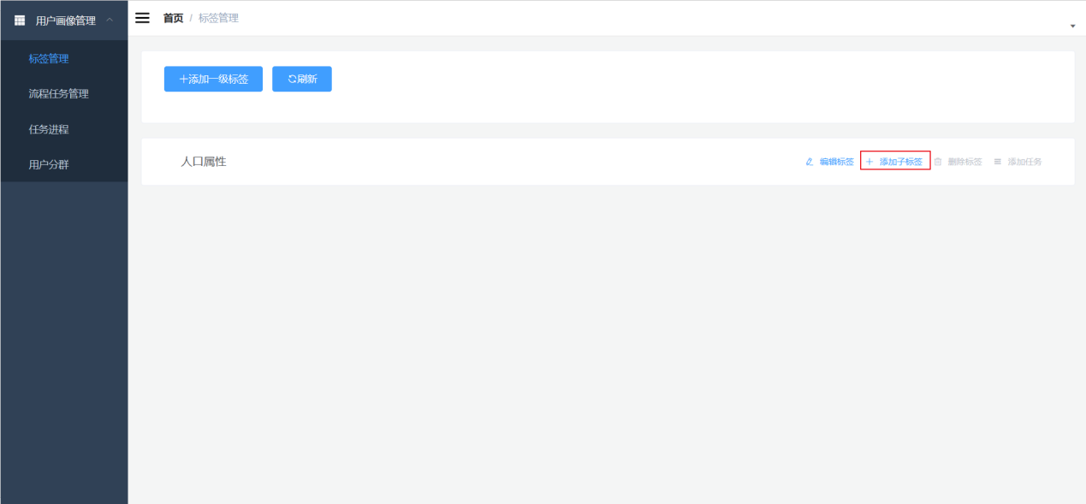

#### 2) Enter label information

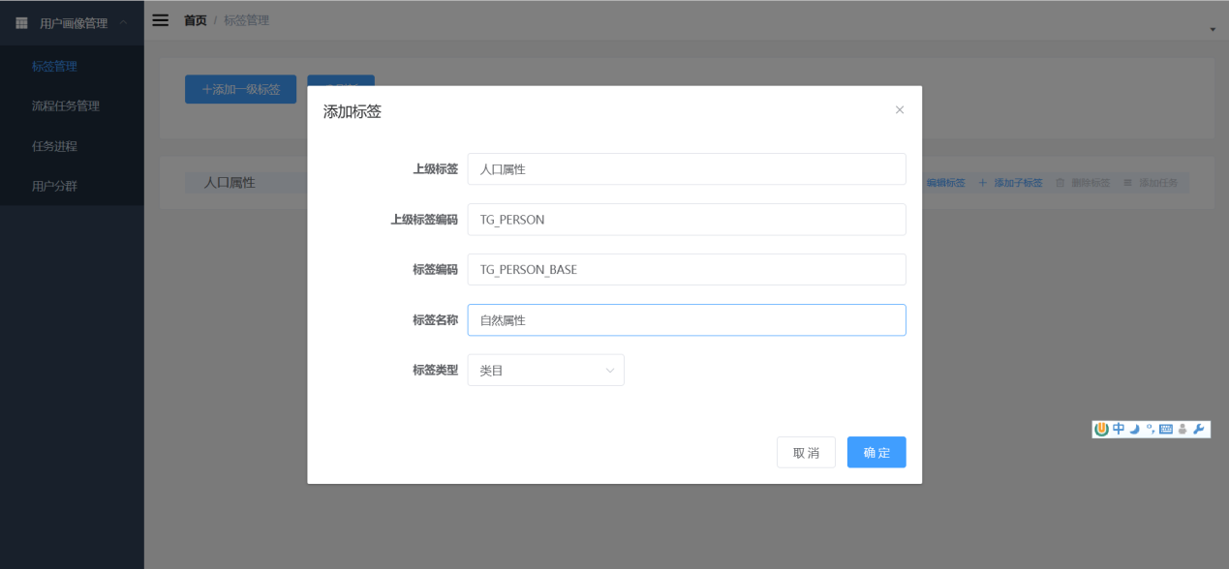

****Note that the coding should reflect the hierarchy

### 4.2.3 Add three -level labels

#### 1 ) Select Add Sub-Tag on the right side of the secondary tag.

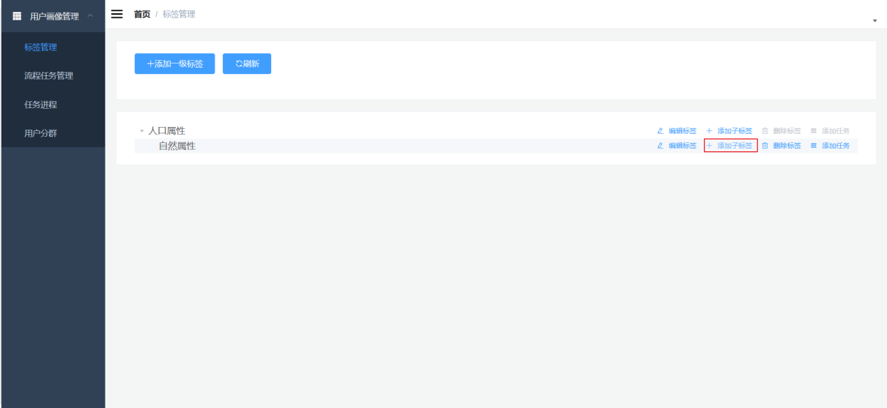

#### 2) Enter label information

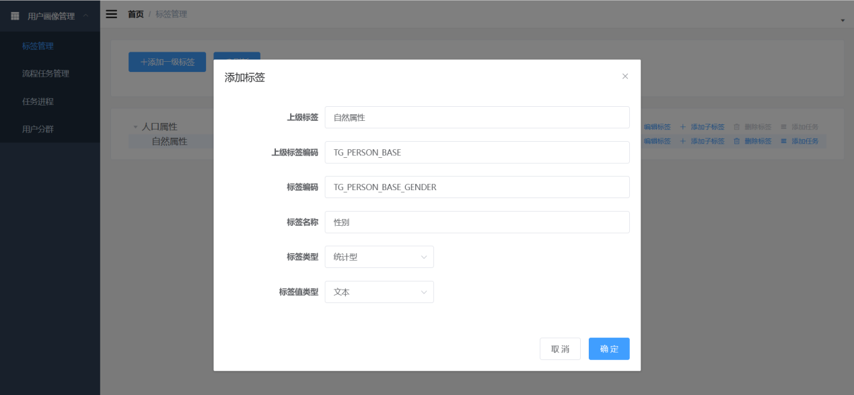

### 4.2.4 Added four- level labels

#### 1 ) Select Add Sub-Tag on the right side of the third-level tag.

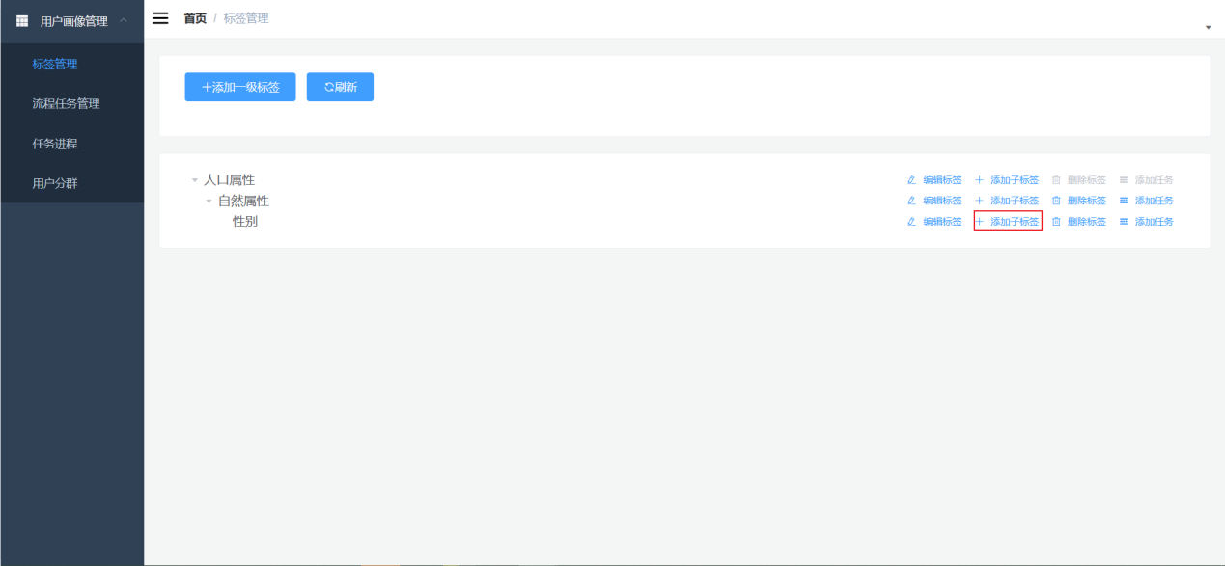

#### 2) Enter label information

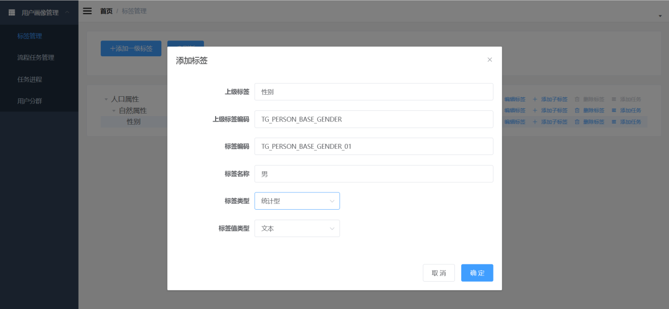

### 4.2.5 This function corresponds to: tag table tag-info field

|  |  |  |
| --- | --- | --- |
| **Mysql- field name** | **Field Description** | **Value Description** |
| **id** | Tag primary key |  |
| **tag_code** | Label Encoding |  |
| **tag_name** | Tag Name |  |
| **tag_level** | Tag level | 1, 2, 3, 4 |
| **parent_tag_id** | Parent tag ID |  |
| **tag_type** | Tag Type | 1. Statistical type, 2. Rule type, 3. Mining type |
| **tag_value_type** | Tag value type | 1 integer, 2 floating point, 3 text, 4 date |
| **tag_task_id** | Tag Task Number |  |
| **tag_comment** | Label Description |  |
| **update_time** | Update time |  |
| **create_time** | Creation time |  |

## 4.3 New tag task (first-level tag is not allowed) (execution method S PARK_SQL , S PARK_JAR ) -spark sql type is stored in mysql?/jar package type is stored in hdfs

### 4.3.1 Add new tag tasks

#### 1 ) Select Add Task on the right side of the tab

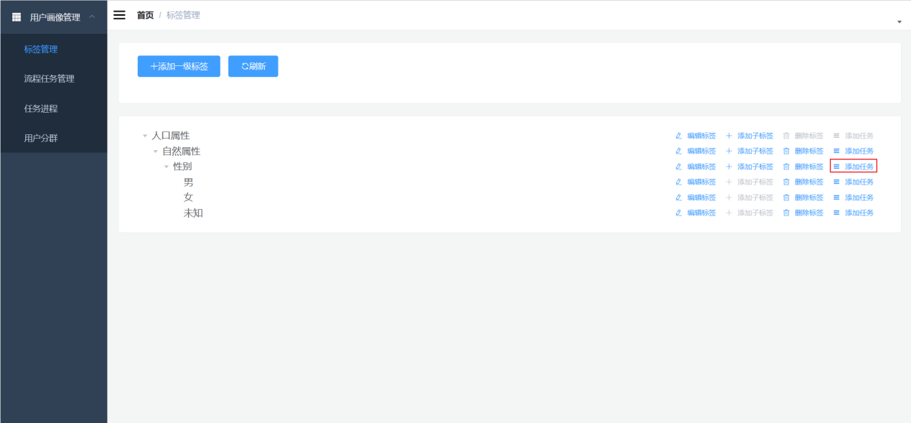

#### 2) Fill in the task information

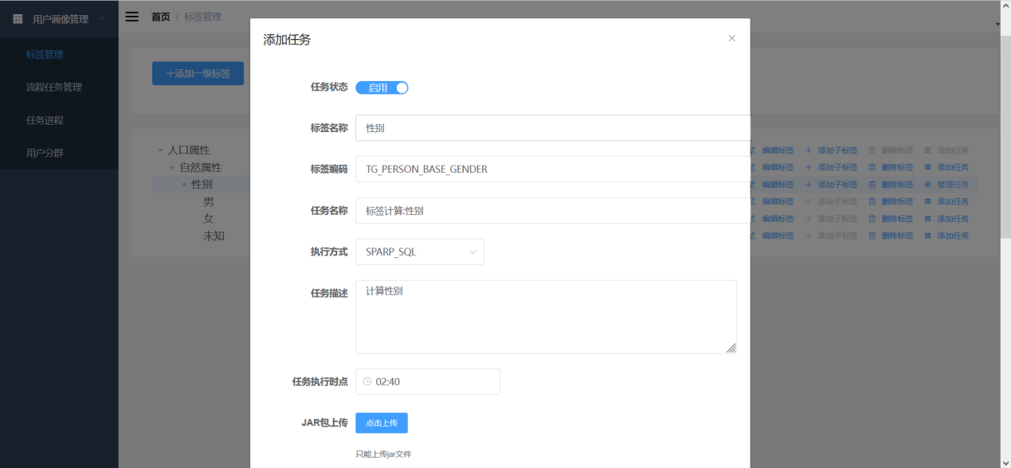

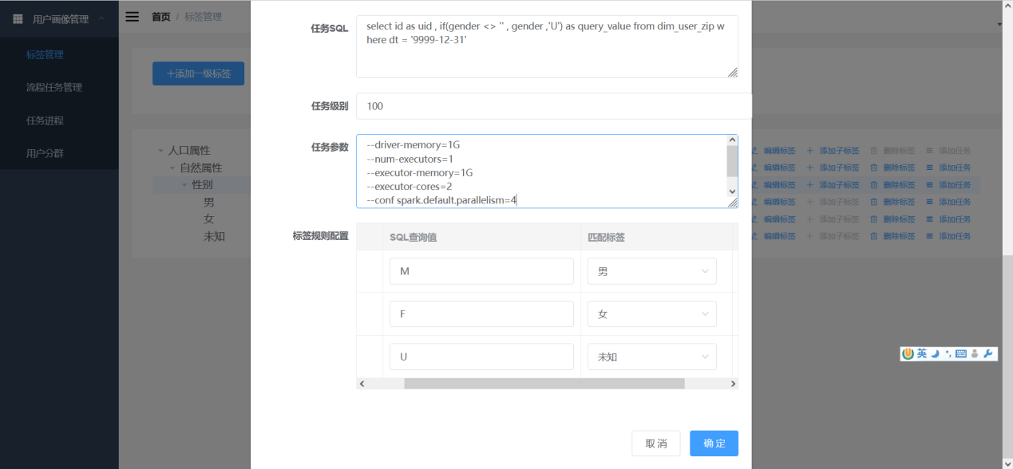

#### 3 ) After adding, it will be displayed as enabled

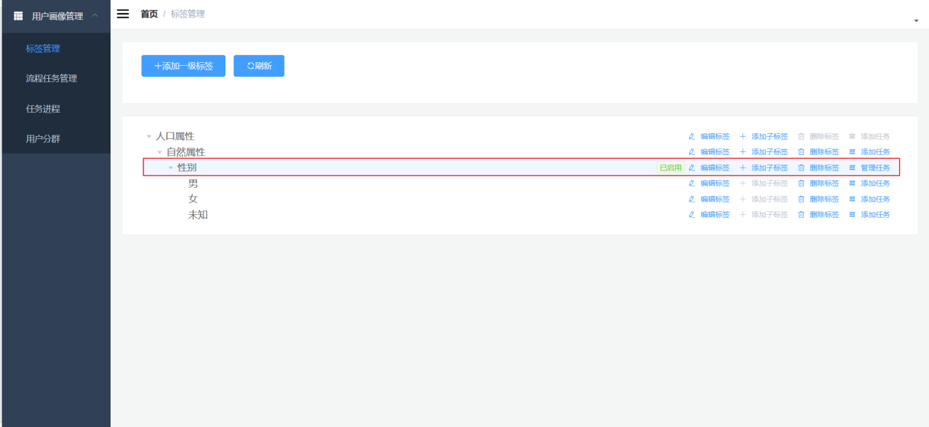

### 4.3.2 Description of the task-info field corresponding to this function

|  |  |
| --- | --- |
| **Page Fields** | **illustrate** |
| **Task Status** | Only task platforms that are enabled will be scheduled regularly |
| **mission name** | mission name |
| **Implementation modalities** | S PARK_SQL 、 S PARK_JAR  **PARK_JAR for complex rule-based labels or mining-based labels, and use S PARK_SQL for general statistics and simple rules.** |
| **Tag Type** | Level 1 and 2 selection categories, level 3 and 4 selections: value, floating point, text, date |
| **mission details** | Task description information |
| **operation hours** | The time to run this tag task every day |
| **Task S QL** | **S PARK_SQL execution mode** is selected, the system automatically **calculates based on the SQL filled in this field; the SQL query result must be two columns, one for UId and one for query_value** |
| **Task Level** | The execution order of tasks is determined by level. **The smaller the level number, the earlier it is executed** . The default value is 1 00. |
| **Task parameters** | The parameters submitted when submitting the s park program, master , deploy-mode , class , and executed jar package do not need to be written.  For example:  --driver-memory=1G  --num-executors=1  --executor-memory=1G  --executor-cores=2  --conf spark.default.parallelism=4  an equal sign before the parameter and value , without a space .  for master is y arn ; the default value for deploy-mode is cluster, which is not required. |
| **Tag rule configuration ?** | **Map the query_value generated by the SQL statement to the fourth-level label (label value)** . |

# Chapter 5 (mian3) Tag task development and upload: SQL processing of statistical and rule-based tags

## 5.1 ( mian3 ) Overall processing flow

Although a labeling task has been completed, it is not enough to generate labels by SQL alone . It is also necessary to combine other rules in the task definition to calculate the label data.

Then the step of " **definition + rule + SQL = label** " needs to be completed by as park program Jar package and stored in HDFS .

**as a task process to be executed** at **0:00 am every day or manually** .

When the task progress requirements are met ( 1 Task execution time, 2 task execution level ), **push the job submission information in JSON format to the remote task submitter.**

**The task submitter generates s park-submit and related parameters based on the JSON combination and submits Y ARN** . (Task submitter; Java code implementation required).

**Y ARN will generate a Spark job based on the J AR package path when submitted .**

During the execution phase of the Spark job, **the tag definitions, rules, and SQL in the My SQL library will be read** to query the data in Hive, **generate** tags through calculation, and finally write them into a tag table in the portrait library.

**When the park job is submitted, the remote submitter will always monitor the running status of the job and pass it to the user profile management platform yarn task information through** callback **for monitoring .**



## 5.2 Mission objectives

Complete the JAR package for S park job execution:

**Read tag definitions and rules, combine them into SQL ,** execute them in the data warehouse, and write them into the portrait tag library.

## 5.3 *Analysis of general SQL task development steps

(1) Query task information

(2) Query tag information

( 3 ) Query sub-tag corresponding rules

(4) Generate a tag table (if it does not exist)

(5) Combination writing tag SQL

(6) Execute SQL

## 5.4 Code Implementation

### 5.4.1 Create a database

Database preparation, create a database in hive.

create database user_profile;

### 5.4.2 Project Construction

in idea and name it user-profile-task .

### 5.4.3 Adding Dependencies

Add the following dependencies and dependency management in the pom.xml file .

Java8;Spark3.0.0;

spark-core_2.12 , provided ; spark-sql_2.12 , provided ; mysql-connector-java, etc.

### 5.4.4 Add task -common module

In this project, multiple t ask sub-modules will be implemented in the future . These t ask sub-modules require some common tool classes and entity classes.

5.4.4.1 Create task -common module

**1 ) Create a task-common module under the user -profile-task project**

**2 ) Add the packaging plug-** in maven-assembly-plugin in **pom.xml**

5.4.4.2 Add configuration files **hive -site.xml; configuration.properties ; log4j.properties in the resource directory**

5.4.4.3 Add the **MySqlUtil tool class for Mysql query and** **MyPropsUtil for configuration file parsing**

5.4.4.4 Add entity class

**1 )** **TagInfo** **; TaskInfo ; TaskTagRule**

5.4.4.6 Add Query DAO

**1 ) TagInfoDao** **; TaskInfoDao ; TaskTagRuleDao**

### 5.4.5 (mian3) Added ask -sql module : Complete SQL processing of tags

5.4.5.1 Create task-sql module : Create task -sql module under user -profile-task project

5.4.5.2 Add dependencies - pom.xml adds common module dependencies and packaging plug-in maven -assembly-plugin

5.4.5.3 * Main development task: Calculate labels based on SQL definitions

/**

* Development task: Calculate tags based on SQL definitions

the business parameters passed in spark-submit ; that is, task_id

* 2. Query mysql according to task_id to obtain the corresponding task_info, tag_info, task_tag_rule information

* That is, the tag name, tag code, defined sql, and the mapping relationship between the calculated value and the tag value

* 3. Before generating a tag, check whether there is a table with the tag. If not, create a hive data table for the tag.

* 4. Dynamically concatenate an insert select SQL based on SQL and mapping

* 5. Execute the sql

*/

## 5.6 Debugging and running

**1 ) Before executing the task-sql module, first make the task-common module install .**

**2 ) When running for the first time, configure the execution parameters as shown below:**

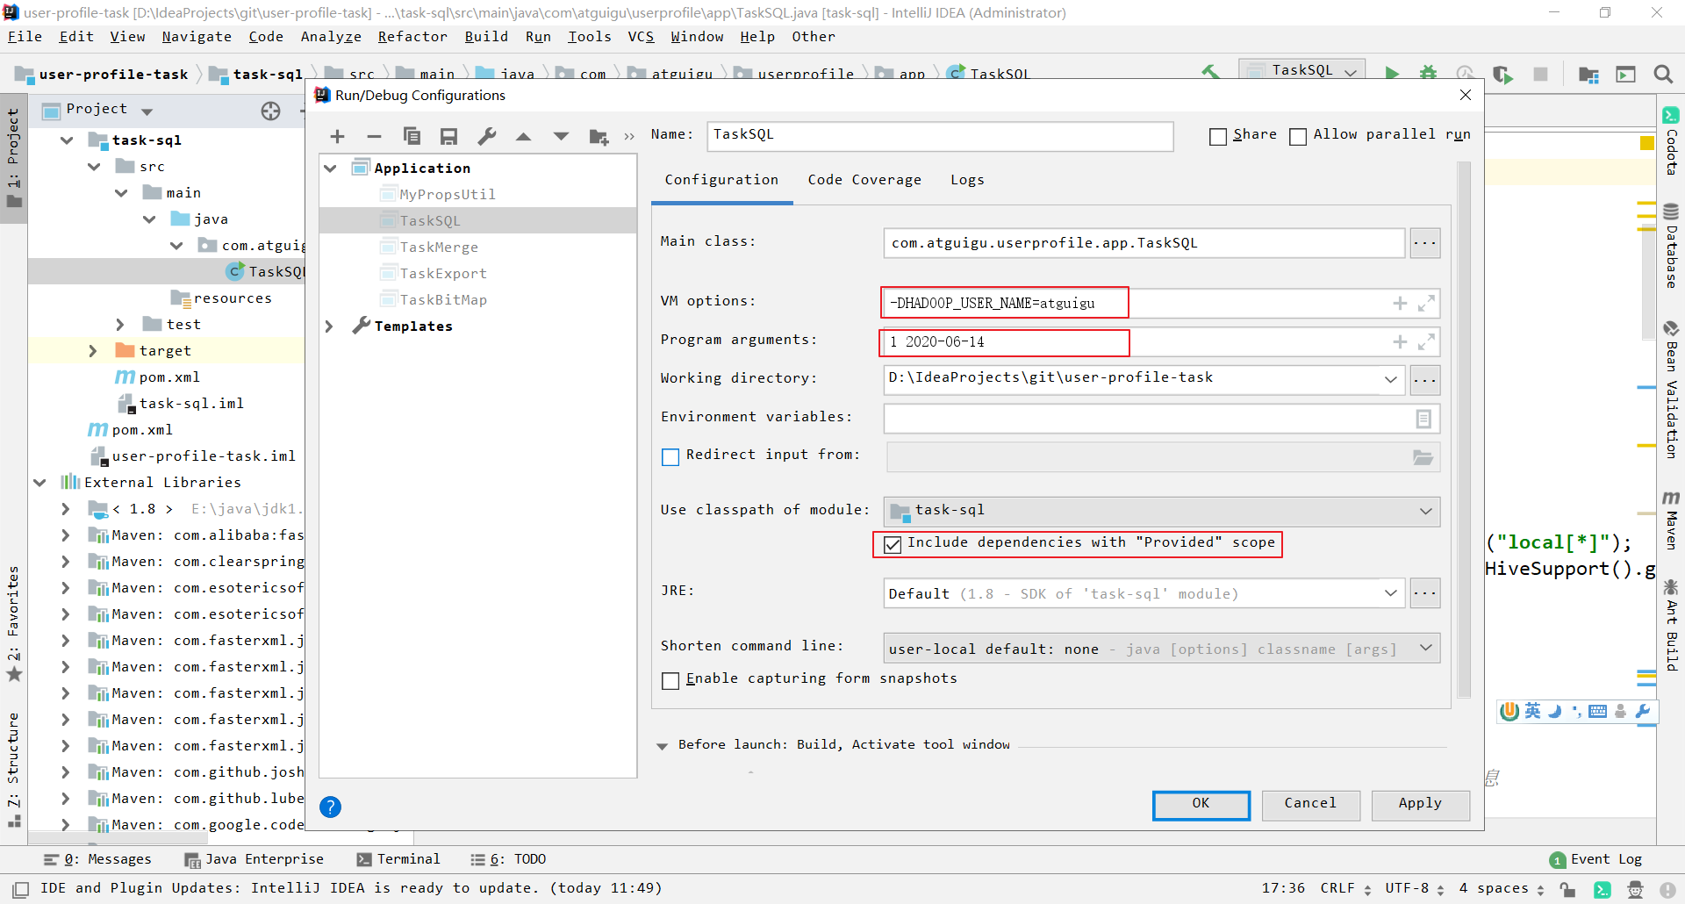

* V M options : The HDFS user must be specified at the end , otherwise insufficient access rights will be reported (if - DHADOOP_USER does not work, you can replace it with - DHADOOP_USER _ NAME )
* Program arguments: It must be followed by two parameters. The first is the id of ask_info in the database , and the second is the date of execution of the business .
* Checking the "Provided" scope means that the dependencies marked as Provided in the Maven dependencies will not be included in the package, but they will still be loaded during debugging.

After the operation is successful, go to hive to check whether there is a corresponding label table under the user_profile database and whether the data is correct, for example:

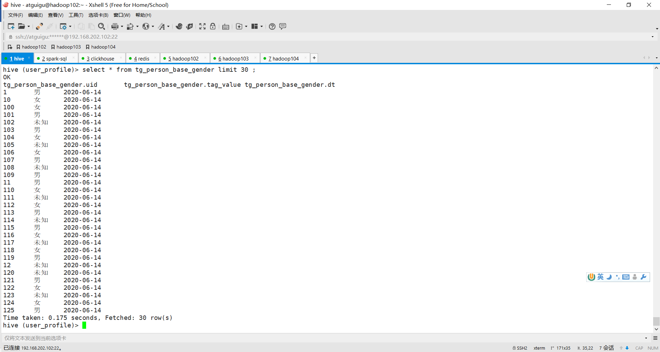

## 5.7 Upload the general jar package of the general SQL task - functional test

### 5.7.1 Preparation

**1 ) First, comment out .setMaster(" local [*]") in the program.**

SparkConf sparkConf = new SparkConf().setAppName("task_sql_app"); //.setMaster("local[*]");

**2 ) Run make install on the user-profile-task module and task-common module**

**3 ) Package the task- sql module with Maven**

**4 ) Check the jar packages in the task -sql module , one with dependencies and one without dependencies in the target directory**

### 5.7.2 Program upload

#### 1 ) In the process task management, click Upload SQL task general jar package

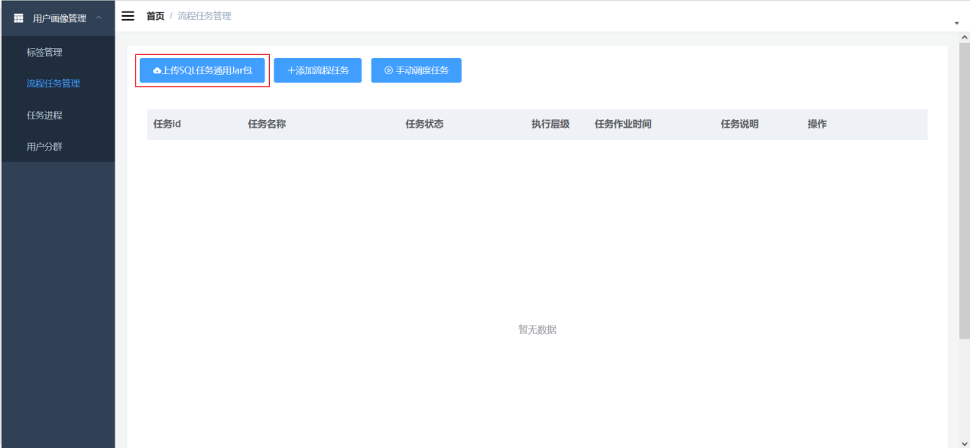

#### 2 ) Fill in the task main class and upload the jar package

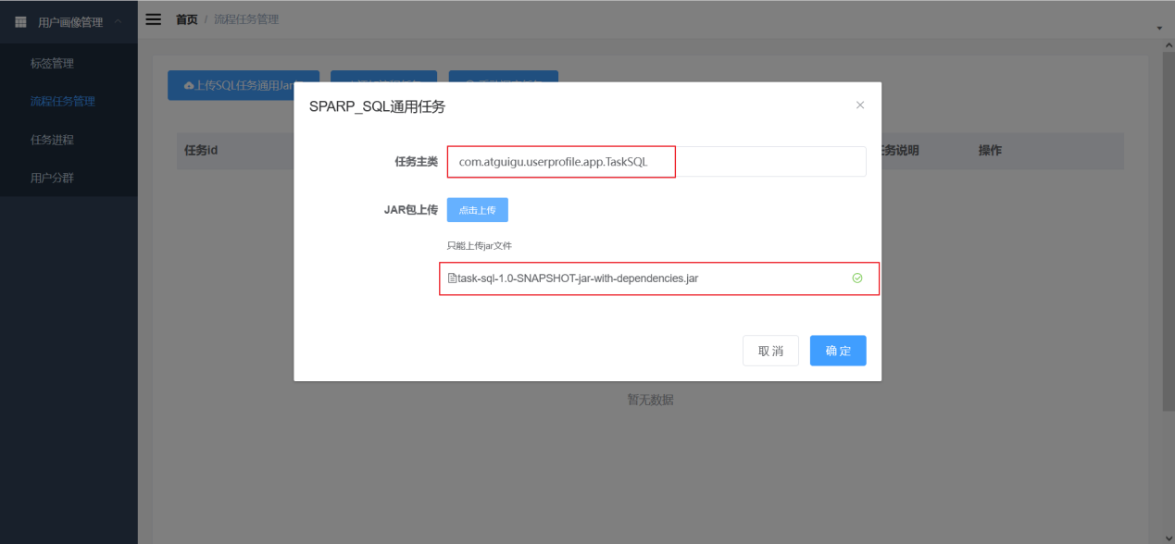

#### 4 ) Database table : **general label general SQL dedicated table and HDFS file table**

**General tag general SQL dedicated table, currently this table actually only stores one row of data.**

|  |  |
| --- | --- |
| **Fields** | **illustrate** |
| **i d** | Primary Key |
| **t ask_file_id** | Associated file id |
| **main_class** | Task Main Class |
| **u pdate_time** | Last updated |

**Document table**

|  |  |
| --- | --- |
| **Fields** | **illustrate** |
| **i d** | Primary Key |
| **file_name** | file name |
| **file_ex_name** | File extensions |
| **file_path** | file path |
| **file_system** | File system |
| **file_status** | Is it effective? |
| **create_time** | Creation time |

## 5.8 Startup Scheduling

### 5.8.1 Ensure before dispatching

* + HDFS cluster startup
  + YARN cluster startup
  + Spark on Yarn is runnable
  + Remote Submitter Startup

### 5.8.2 Check whether s park on yarn is working properly (must check)

**1 ) First, execute echo $PATH in Linux to check the location of spark .**

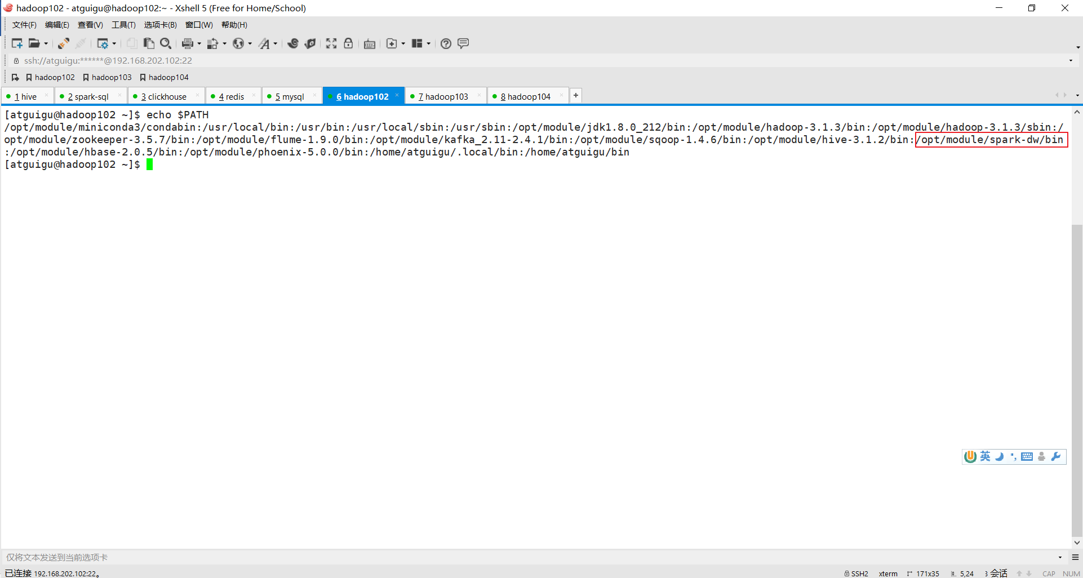

**2) If the spark environment variables are missing , add them in the environment variable configuration file**

**conf/spark_env.sh in the spark directory and make sure it contains yarn-related configurations**

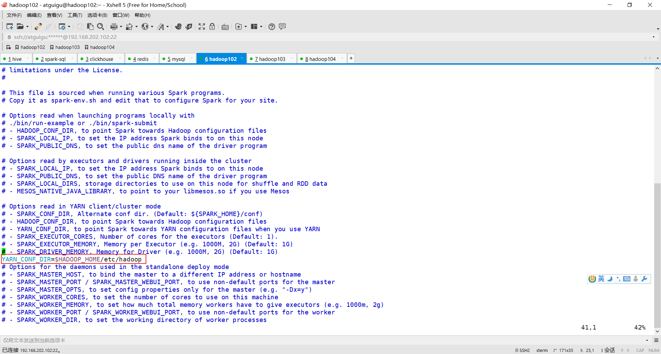

### 5.8.3 Deploy the remote submitter

**1) First upload the three files of the submitter to the / opt / module / spark-rest (self-built) directory in Linux**

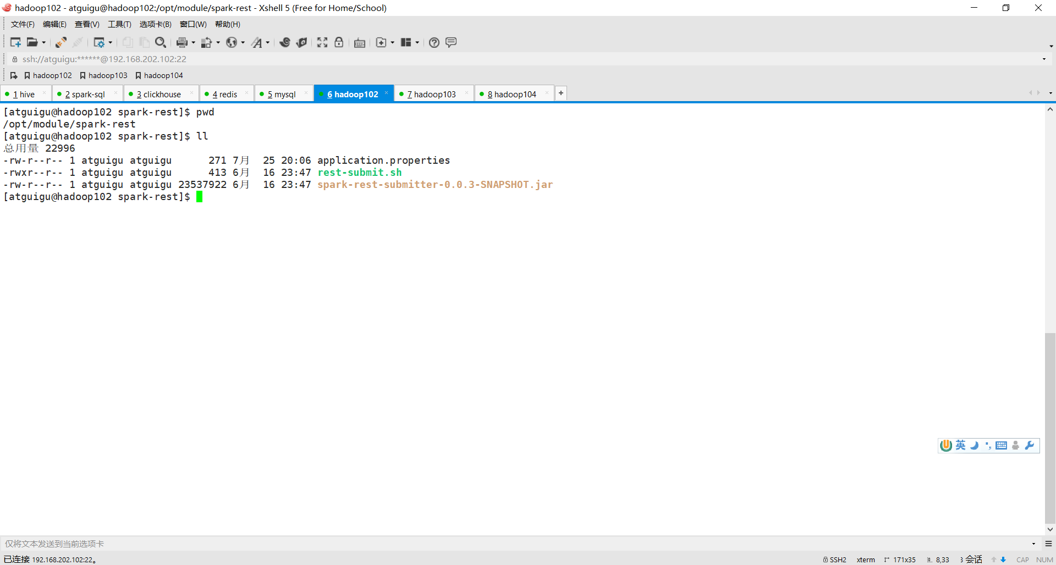

**2) Modify the callback address of the submitter in application.properties**

server.port=8266

spring.application.name=spark-rest-submitter

logging.level.root=info

logging.level.com.atguigu.spark.submitter.service.impl.SubmitterServiceImpl=info

callback.type=http

callback.http.url=http:// 192.168.202.1 /callback/task-status

The callback address is used to send the Y **ARN status obtained by the submitter back to the portrait platform** . **The portrait platform is deployed in Windows, so the Windows address must be written** . If the callback address is not written correctly, the status of the portrait task will be fixed at START.

**3) Give execution permission to rest-submit.sh**

[atguigu@hadoop102 spark-rest]$ chmod u+x rest-submit.sh

**4 ) Start the remote submitter**

[atguigu@hadoop102 spark-rest]$ ./rest-submit.sh

--------Start remote submitter-------

### 5.8.4 Submitting tasks

**1) In [Process Task Management], click [Execute on a specified date]**

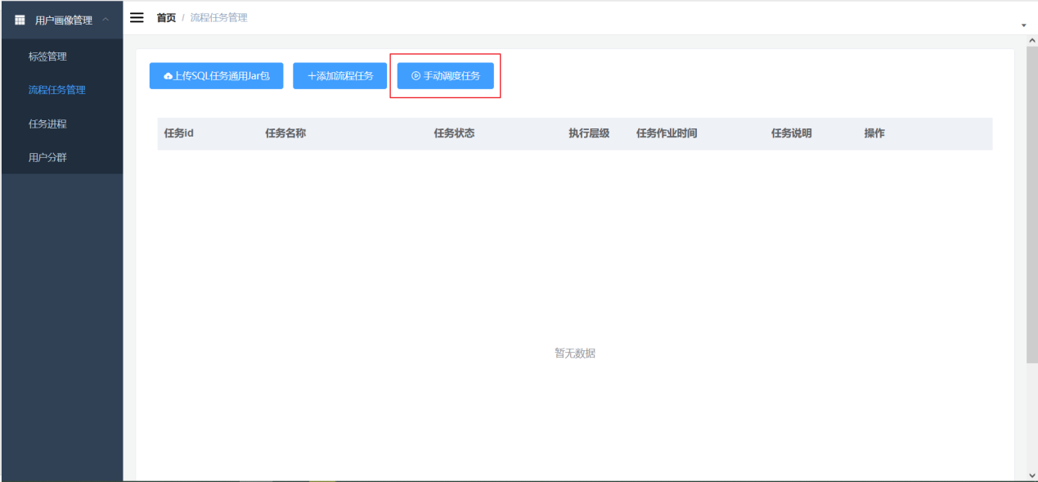

**2) Fill in the business date to be calculated (fill in according to the date of the data warehouse)**

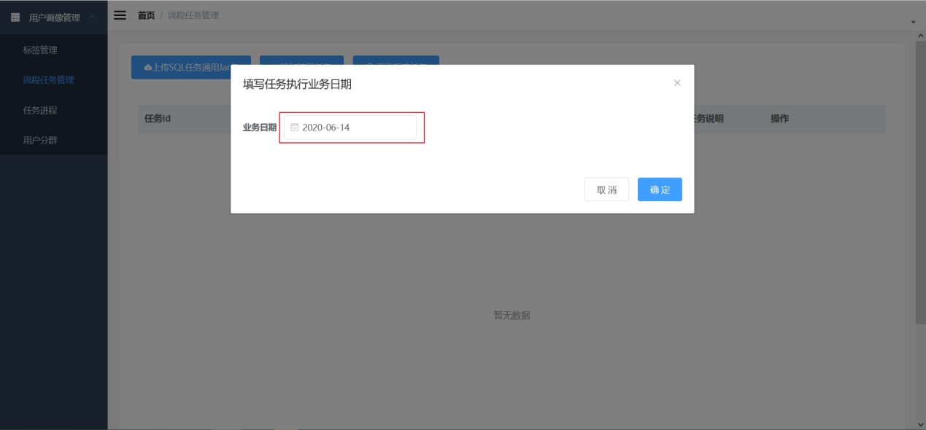

**3) Click OK**

**4) Go to [Task Progress ] to view the submitted tasks and observe the changes in the task execution status**

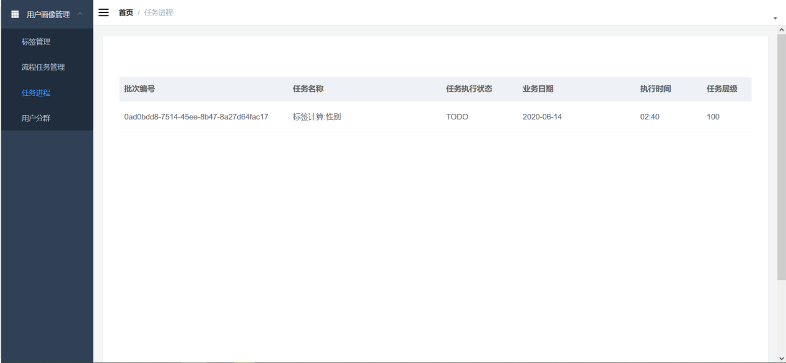

Note: Task progress is not necessarily submitted directly to Y ARN .

Two other conditions apply:

① Are there any tasks with lower levels in the same batch?

②Whether the execution time point has been reached.

When the conditions are met, the task status will change from "TODO" to "START" , and finally to FINISHED or FAILED

arn application id generated by the callback to go to the Y arn console to view the specific error log of the corresponding job.

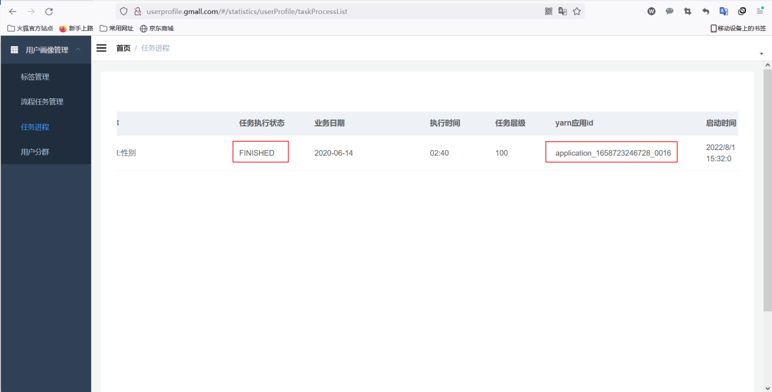

## 5.9 Result verification

**1 ) First, make sure the task's execution status changes to [ FINISHED ]**

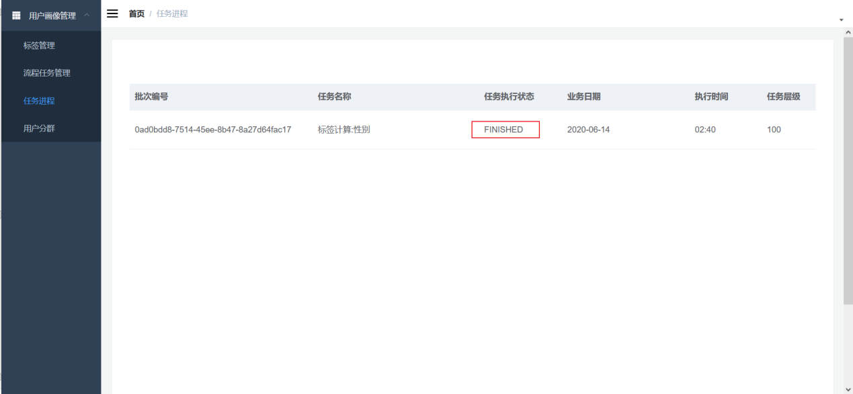

**2 ) Check in Hive whether the corresponding tag table is generated**

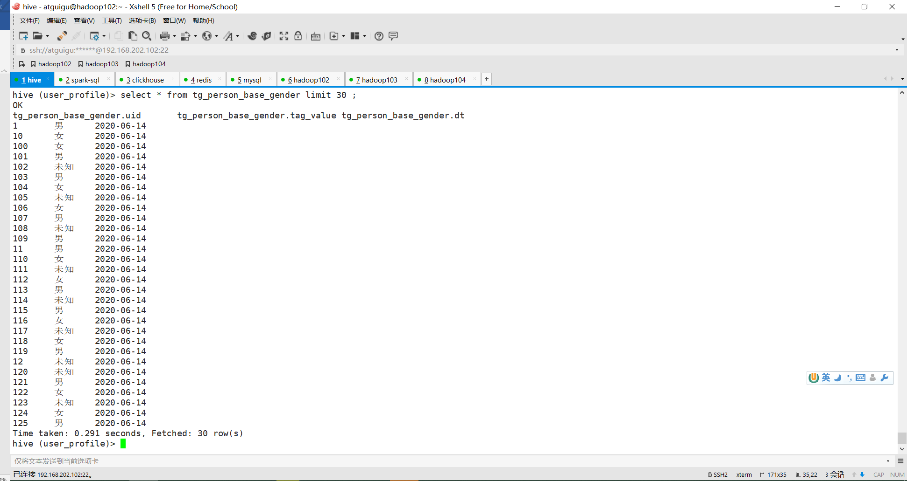

# Chapter 6 (mian4) Process Task Merge Task Development and Upload: Complete the Wide Table Merge of Labels

## 6.1 Mission objectives

**A wide table with user ID as the primary key** is created to facilitate querying and exporting data. Each column in the wide table uses **the third-level tag number as the column name** .

|  |  |  |  |  |  |
| --- | --- | --- | --- | --- | --- |
| **u id** | **person_base_agegroup** | **person_base_gender** | **person_behavior_xxcount** | **…..** | **…..** |
| **1 010** | Post - 90s | male | 1 2000 | … | … |
| **1 011** | 80 's | female | 2 3000 | … | … |
| **1 012** | …. | … | …. | … | … |

This large wide table contains all the tags, and there are as many columns as there are tags.

## 6.2 Design analysis

(1) Read the tag list of all started tag tasks

(2) Read the tag code and tag value type in the tag list, obtain the field name and field value, and splice them into a table creation statement

(3) Combine multiple tables according to the label list, convert rows into columns, and combine them into an insert select statement.

## 6.3 About Pivot

**p ivot** , S park - sql , Oracle-specific keywords, namely **rotation** , will refer to the column field value, rotate into multiple columns. And you can specify some columns to become the aggregate value of the rotation column.

### 6.3.1 Case 1

**1 ) Table**

CREATE TABLE test_order_info

(uname STRING, product STRING, age INT, city string, amount decimal);

INSERT INTO test_order_info VALUES

( 'zhang3' , 'tv' , 22 , 'bj' , 3000),

( 'li4', 'notebook', 41, 'bj', 8000),

( 'wang5', 'phone', 32, 'sh', 4000),

( 'zhao6', 'notebook', 22, 'sz', 3000),

( 'zhang3', 'phone', 22, 'bj', 3000),

( 'li4', 'tv', 41, 'sz', 4000) ;

**2) Ask**

|  |  |  |  |  |  |
| --- | --- | --- | --- | --- | --- |
| **uname** | **a ge** | **tv_amount** | **notebook_amount** | **phone_amount** | **…** |
| **z hang3** | twenty two | ? ? | ? ? | ? ? |  |
| **i4** |  |  |  |  |  |
| **w ang5** |  |  |  |  |  |
| **zhao6** |  |  |  |  |  |
| **…** |  |  |  |  |  |

**3) sql**

select * from test_order_info pivot ( sum(amount) as amount for product in ('tv','notebook','phone' ))

### 6.3.2 Pivot principle description

Arrange the entire table into three types of columns: **dimension columns, pivot columns, and aggregate columns** .

**1) Format**

select * from table name pivot ( sum( aggregate column ) as column identifier for pivot column in( pivot column value 1 , pivot column value 2, pivot column value 3 ) )

**2) Rotate the columns**

The original row value of a column is now to be converted from the row value to the column field (the product in the above example )

**3) Aggregate columns**

For the new column after pivoting, the value to be aggregated ( amount in the above example )

Except for pivot columns and aggregate columns, all are dimension columns by default. If there are fields other than these three, you need to remove them in advance using a subquery ( uname and age in the above example ).

### 6.3.3 Case 2

**1 ) Ask**

|  |  |  |  |  |  |  |  |
| --- | --- | --- | --- | --- | --- | --- | --- |
| **product** | **bj_amount** | **bj_avg_age** | **sh_amount** | **sh_avg_age** | **sz_amount** | **sz_avg_age** | **…** |
| **notebook** | ? ? | ? ? | ? ? | ? ? | ? ? | ? ? |  |
| **phone** |  |  |  |  |  |  |  |
| **tv** |  |  |  |  |  |  |  |
| **…** |  |  |  |  |  |  |  |

**2) sql**

select * from (select product,age,city,amount from test_order_info ) oi

pivot ( sum(amount) as amount ,avg(age) as age for city in ('bj','sh','sz' ))

**3 ) The test requires the use of sparksql , hive does not support pip**

spark-sql --hiveconf hive.cli.print.header=true

### 6.3.4 Case 3

**1 ) Table**

create table test_user_tags (uid string, tag_code STRING, tag_value STRING);

INSERT INTO test_user_tags VALUES

( '101', 'gender' , 'f' ),

( '102', 'gender', 'm' ),

( '103', 'gender', 'm' ),

( '104', 'gender', 'f' ),

( '105', 'gender', 'm' ),

( '106', 'gender', 'f' ),

( '101', 'age' , '60' ),

( '102', 'age', '70' ),

( '103', 'age', '80' ),

( '104', 'age', '70' ),

( '105', 'age', '90' ),

( '106', 'age', '90' ) ,

( '101', 'amount' , '422' ),

( '102', 'amount', '4443' ),

( '103', 'amount', '12000' ),

( '104', 'amount', '6664' ),

( '105', 'amount', '900' ),

( '106', 'amount', '2000' ) ;

**2) Ask**

|  |  |  |  |  |
| --- | --- | --- | --- | --- |
| **UID** | **gender** | **age** | **amount** | **…** |
| **101** | ? ? | ? ? | ? ? |  |
| **102** |  |  |  |  |
| **103** |  |  |  |  |
| **…** |  |  |  |  |

**3) sql**

select * from test_user_tags pivot ( max(tag_value) as tv for tag_code in ('gender','age','amount' ))

## 6.4 Code Implementation

### 6.4.1 Add task -merge module

**1 ) Create a task -merge module under the user -profile-task project**

**2 ) Add common module dependency and packaging plug-in** in maven-assembly-plugin in **pom.xml**

### the getTagInfoList method to TagInfoDAO in task-common

### 6.4 . 3 * Main development task: Complete tag merging task

/**

* Merge tags

* 1. Get the calculated business date

* 2. Query MySQL to get all the tags that need to be merged, using tag_code as the column name

* 3. Create a wide table. You cannot create it manually because you are not sure how many columns there are and it may be different every day.

* 4. Use a pivot SQL statement to merge multiple single-label tables into one wide-label table

* Dimension column: uid Rotation column: tag_code Aggregation column: tag_value

*/

### 6.4.4 t ask-merge module structure

## 6.5 Debugging and running

**1 ) Configure execution parameters**

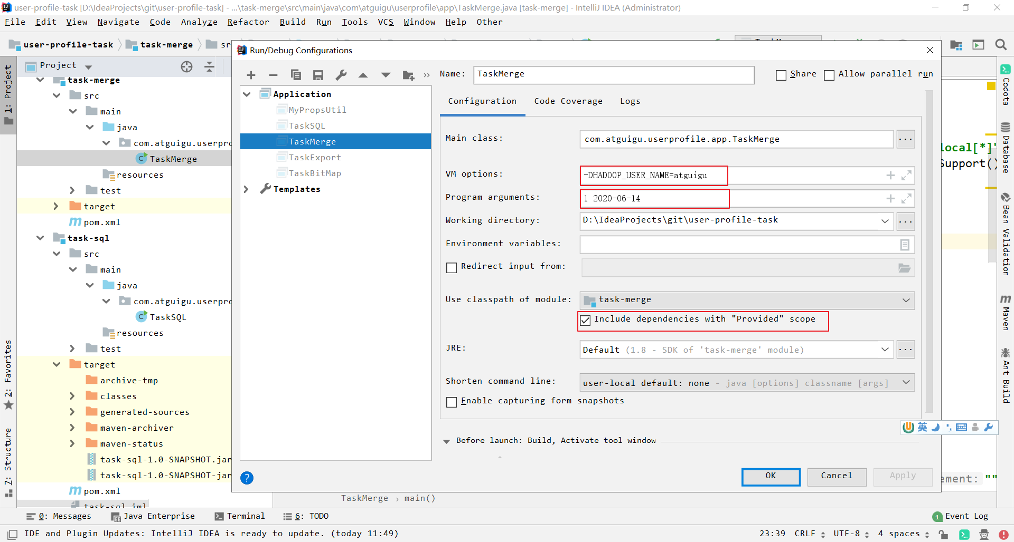

**2 ) View the results**

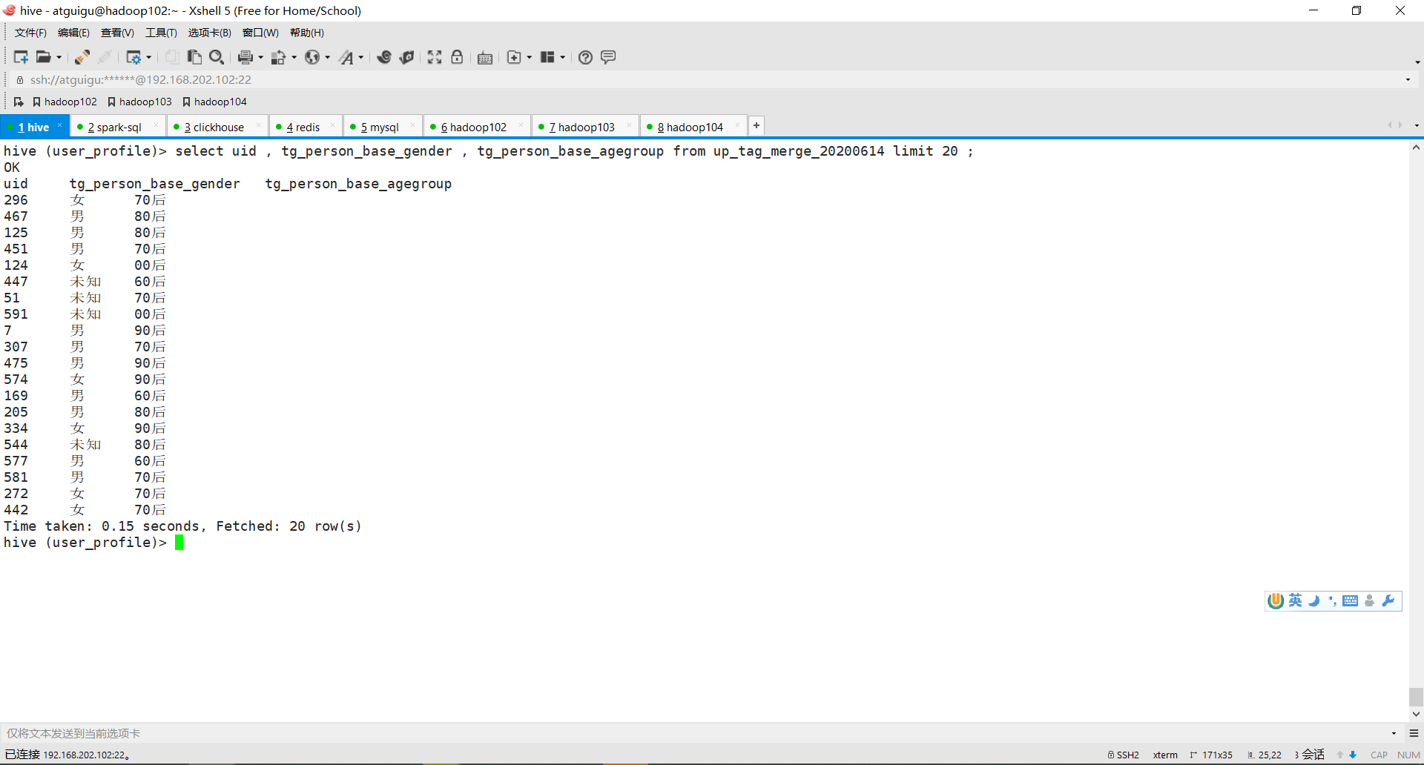

## 6.6Merge task release function test

Because this wide table merging task must be completed after all labeling tasks are executed.

Therefore, you need to **add a new "process task" to manage the merge tasks** . In [Process Task Management], click Add Process Task.

### 6.6.1 Packaging

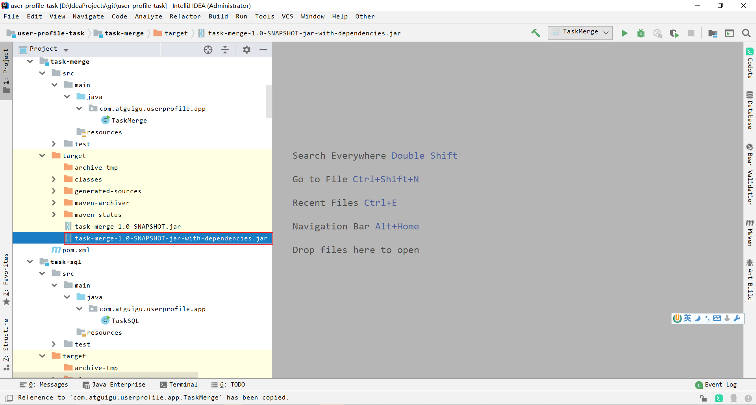

### 6.6.2 Click to add a process task

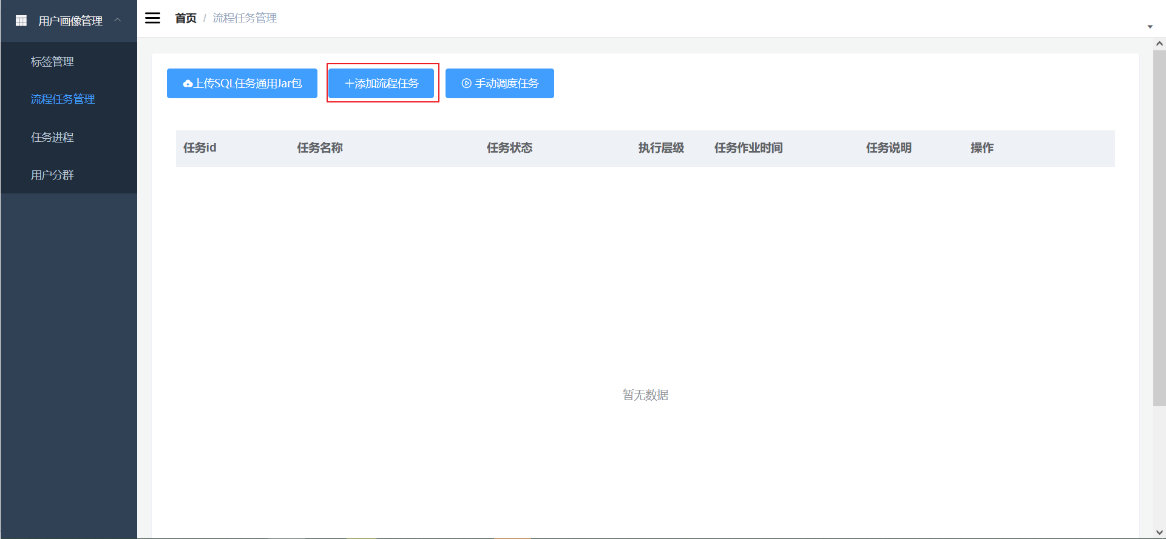

### 6.6.3 Fill in the process tasks

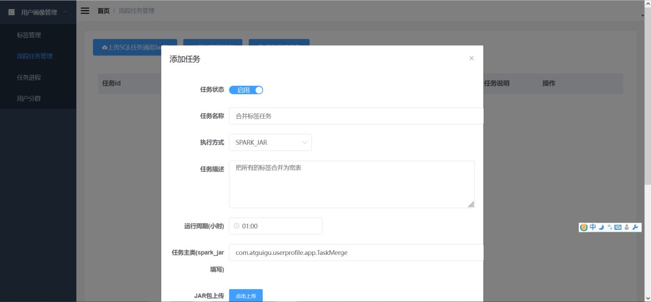

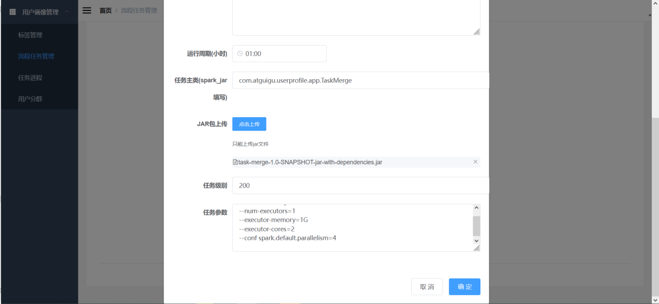

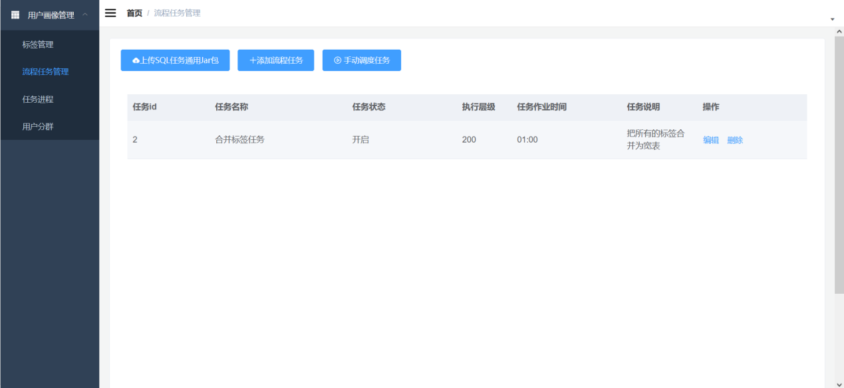

illustrate:

Execution mode selection: SPARK_JAR

Task level: Because it must **be after the tag task, it should be greater than the tag task level (the tag task level defaults to 1 00 ).**

### 6.6.4 Manually Scheduling Tasks

**1) In [Process Task Management], click Manually schedule task to select a scheduling date.**

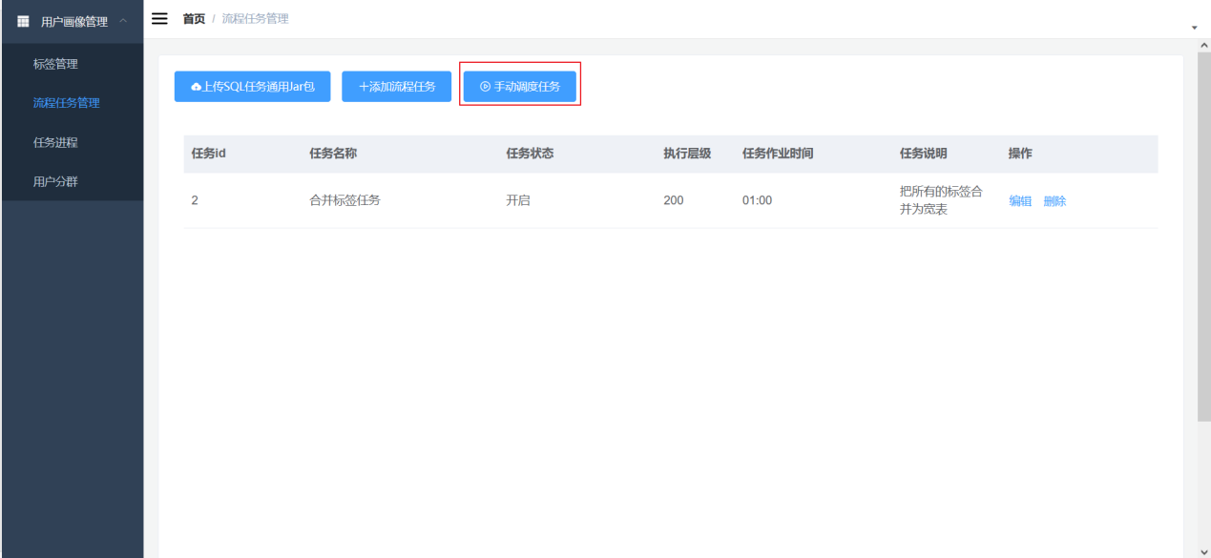

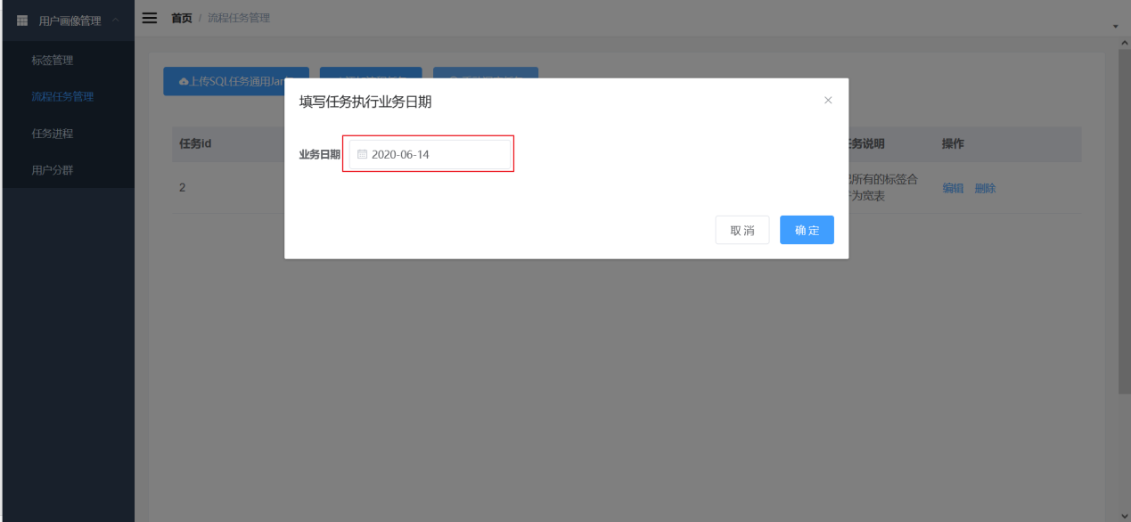

**2 ) Return to [Task Process] and you can see that in addition to the process that generated the label calculation task, there is also the process that merged the task** .

The scheduler (built-in 1 5 seconds) will check whether there are tasks for T ODO and schedule them according to the task hierarchy (priority, similar to the dependencies of ods, dwd, dws, ads, and the order of execution) .

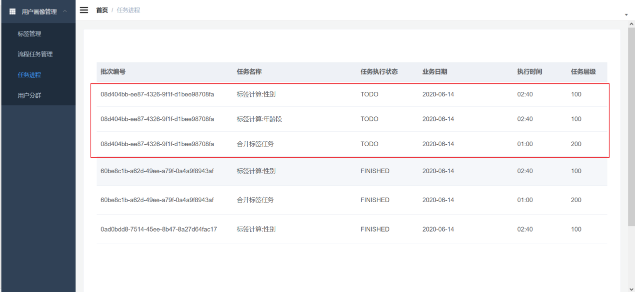

## 6.7 Verification of merged task results

**1) Make sure each task is in FINISHED state**

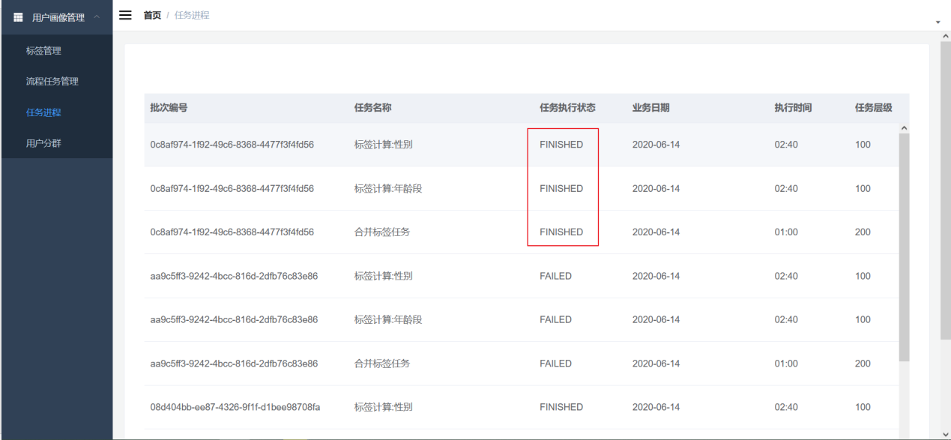

**2) View the merged wide table in Hive**

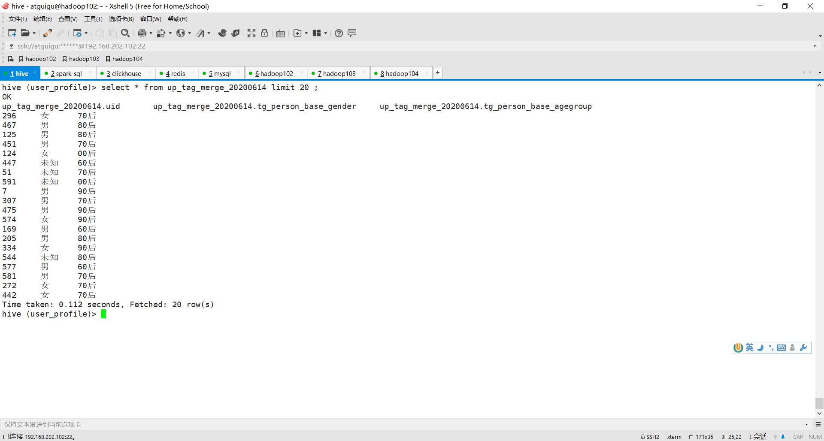

# Chapter VII (mian5) Develop and upload the export task of the process task: export data to C lickhouse

## 7.1 Why Migrate ?

After the tags are calculated and saved in **hive , they can be queried, but the performance is very poor** . **Tags are often used immediately** . The most common scenario is "user grouping", also known as "crowd selection", "grouping people", etc.

The clustering operation is to generate a user set based on multiple tags for use by marketing, advertising and other departments. However, these operations require large amounts of calculations and the results need to be produced in a timely manner.

## 7.2 Solution selection - the most important basis : **data volume and timeliness requirements**

|  |  |  |
| --- | --- | --- |
| **Timeliness** | **The amount of data** | **Grouping plan** |
| **Acceptable the next day** | It doesn't matter | HIVE wide table |
| **Instant generation** | Less than 10 million, 100-level tags | OLAP wide table ( Elasticsearch , Clickhouse , Tidb ,… ) |
| **Instant generation** | **Hundreds of millions of tags** | **B itmap method** ( C lickhouse , **doris** ) |

This course chooses to use Clickhouse to implement B itmap storage.

## 7.3 Preparation - refer to " Clickhouse , Big Data Technology "

## 7.4Task objective - Write the **hive tag wide table data into the Clickhouse wide table** .

## 7.5 Design analysis

(1) Create a corresponding wide table in Clickhouse.

(2) Because it is not a hive table to a hive table, it cannot be solved directly using insert select

You need to first **query the data into a Dataframe using Spark , and then write it to the Clickhouse wide table using an action operator** .

## 7.6 Database preparation -clickhouse creates a database create database user_profile ;

## 7.7Code implementation

### 7.7.1 Add task - export module

**1) Create a task - export module under the user-profile-task project**

**2) Add common module dependency and** maven-assembly-plugin packaging plug-in in **p om.xml**

### 7.7.2 Add configuration

In the tasks -common module config.properties

clickhouse.url=jdbc:clickhouse:// had oop102:8123/user_profile

### 7.7.2 Add execution of lickhouse SQL statement tool class

Because this tool will also be used by other modules, it is placed in the ask-common module

ClickHouseUtil . executeSql

### 7.7.3 Main development tasks: data migration to clickhouse

App main class implementation:

//1. Get the field name set by querying the tag set

//2. Translate the table structure and create a clickhouse table with the same structure and hive table fields

//3. Write data to clickhouse

## 7.8 Debugging and running

**1 ) Configure execution parameters**

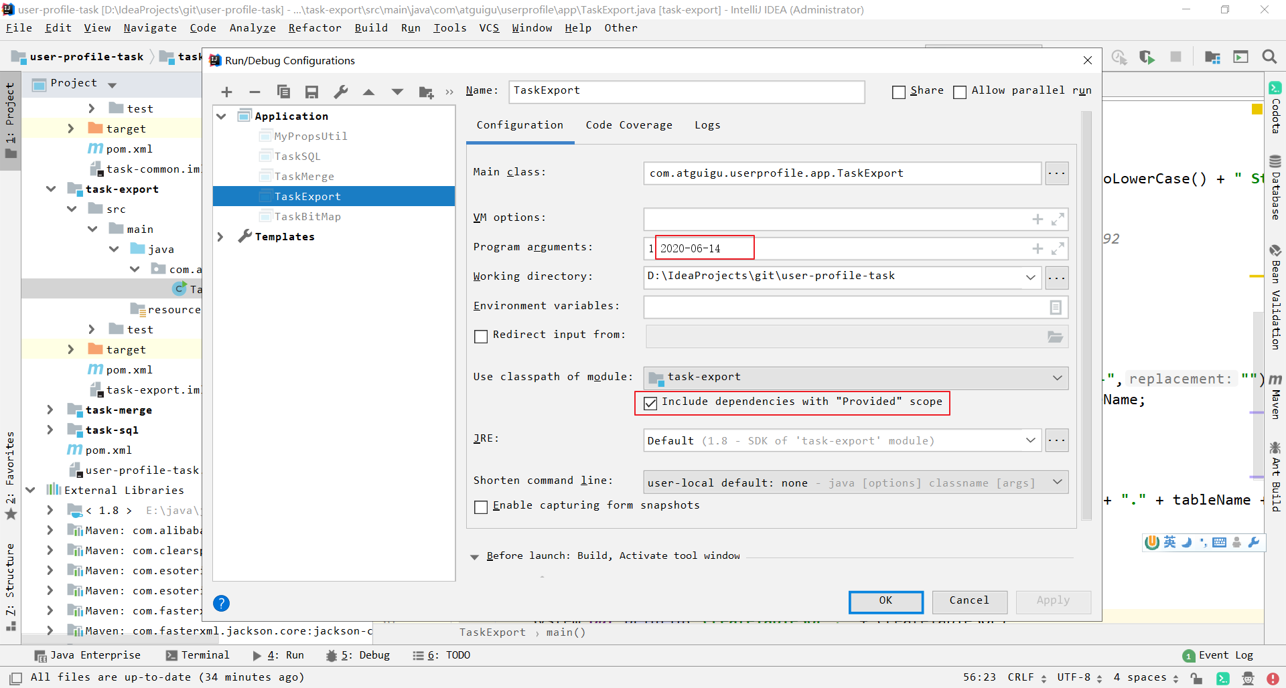

**2 ) View the results in ClickHouse**

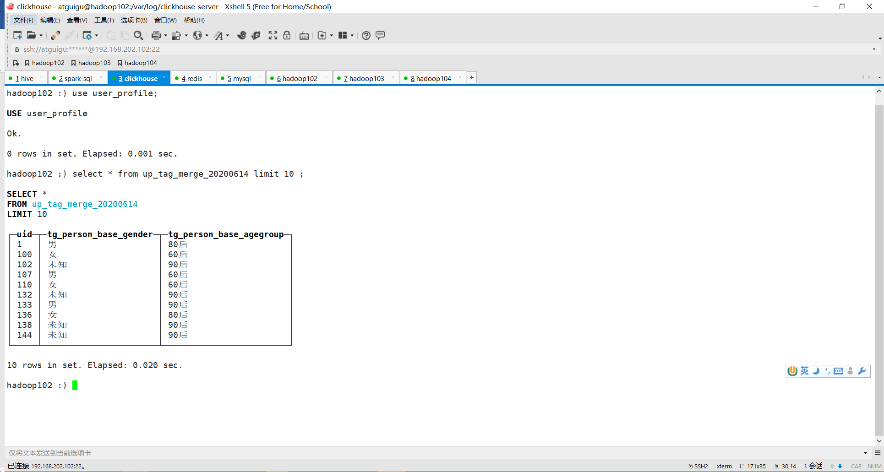

## 7.9 Export task publishing function test

### 7.9.1 Packaging task -export modules: one with dependency jars and one without dependency jars

### 7.9.2 Click Add Process Task



### 7.9.3 Fill in the process task - because it needs to be executed after the wide table merge task, the level is set to 300

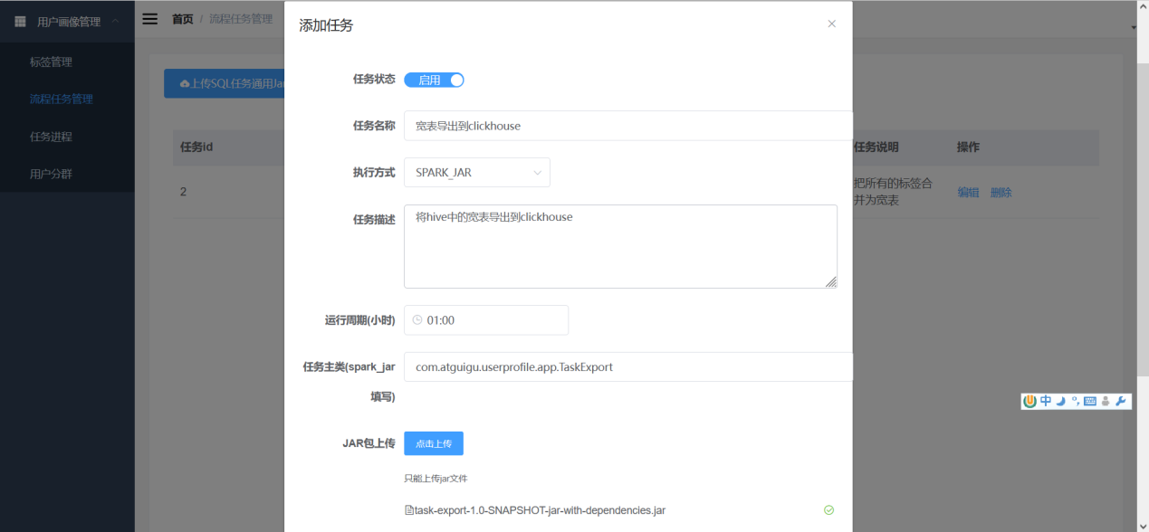

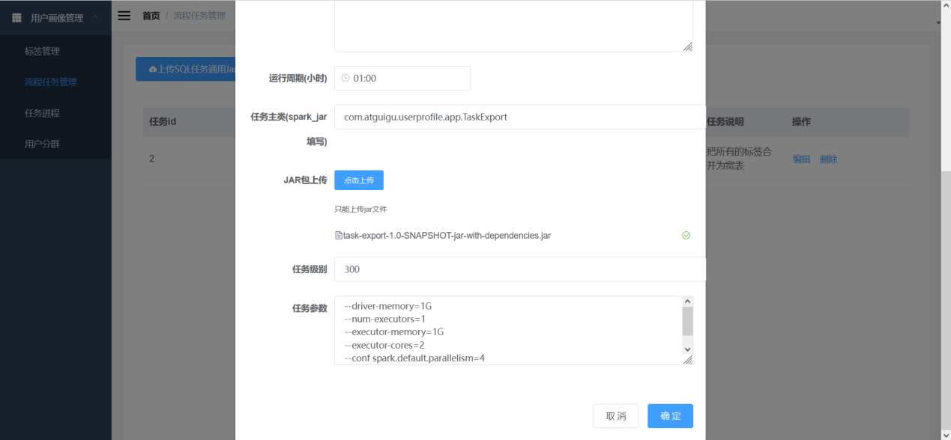

### 7.9.4 Click Manual Schedule Task to select the schedule date .

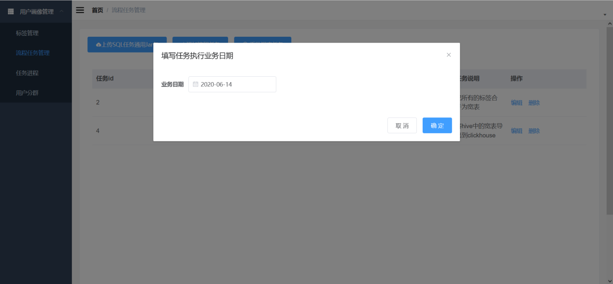

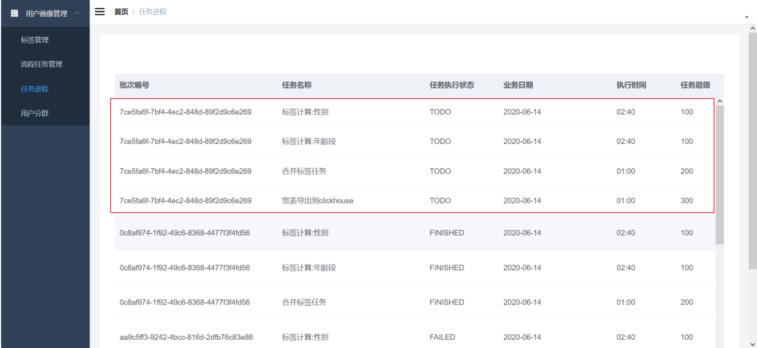

## 7.10 Result verification

### 1) Ensure that the status of each task in the task process is FINISHED

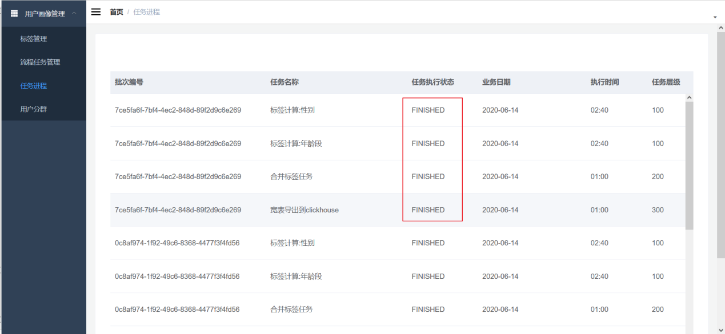

### 2) View the exported wide table in ClickHouse

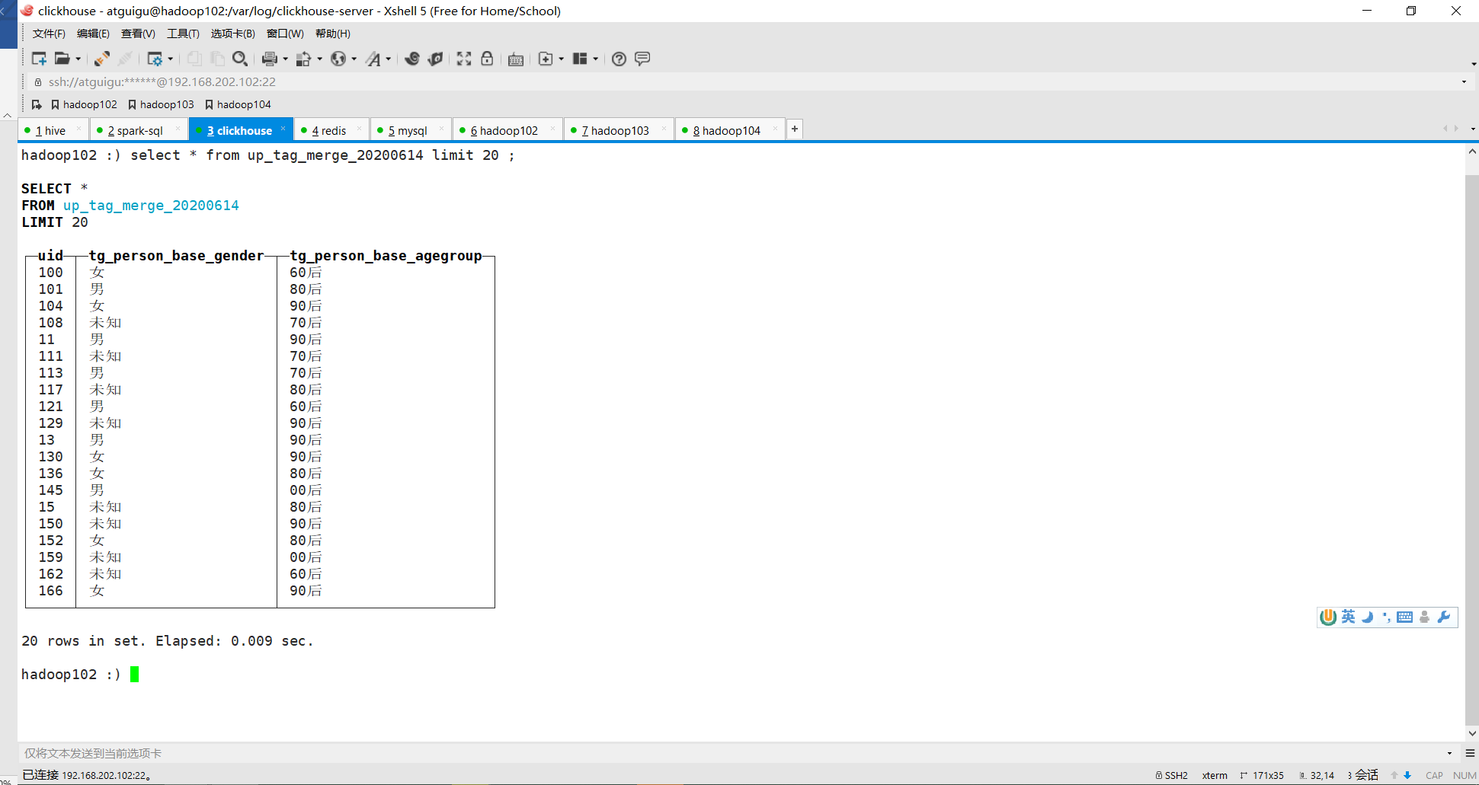

# Chapter eight (mian6) Task 4 : Convert a wide table to a Bitmap table in Clickhouse

## 8.1 Why use Bitmap?

### 8.1.1 Low storage cost

Suppose there is a set of numbers 1 , 2, and 5. If the conventional storage method is used, three Int32 spaces are needed. One Int32 is a 32 -bit space. Three is 3* 32 bits, which is equivalent to 12 bytes .

If we use Bitmap to store it, only 8 bits ( 1 byte) are enough. Each bit represents a number, and the bit number is the value. 1 indicates existence, and 0 indicates non-existence. As shown in the following figure:

|  |  |  |  |  |  |  |  |
| --- | --- | --- | --- | --- | --- | --- | --- |
| **7** | **6** | **5** | **4** | **3** | **2** | **1** | **0** |
| **0** | 0 | 1 | 0 | 0 | 1 | 1 | 0 |

Such a byte can store 8 integers, and the storage cost of each number is actually 1 bit .

That is to say, the storage cost of Bitmap is 1/32 of Array[Int32] and 1/64 of Array [Int64] .

Benefit 1: If there is a very large unordered and non-repeating set of integers, the storage cost of using Bitmap is very low.

### 8.1.2 Natural Deduplication

Benefit 2: Because each value corresponds to only one position and cannot store two values, the Bitmap structure can naturally deduplicate.

### 8.1.3 Rapid positioning

If I have a requirement, for example, I want to determine whether the number "3" exists in the set. If it is a traditional digital set storage, then I have to traverse each element one by one to make a judgment, and the time complexity is O (N) .

However, if it is Bitmap storage, you only need to check whether the value of the corresponding subscript number is 0 or 1, and the time complexity is O(1) .

Query 3

|  |  |  |  |  |  |  |  |
| --- | --- | --- | --- | --- | --- | --- | --- |
| **7** | **6** | **5** | **4** | **→3** | **2** | **1** | **0** |
| **0** | 0 | 1 | 0 | 0 | 1 | 1 | 0 |

Benefit 3: It is very convenient and quick to check whether an element is in the set.

### 8.1.4 Inter - collection calculations

If I have another set 2, 3, 7 , I want to find the intersection of these two sets.

The traditional way to get the intersection of [ 1,2,5] and [ 2,3,7] requires two layers of loop traversal.

Bitmap only needs to perform AND operations on 0 0100110 and 10001100. Computers can perform AND, OR, NOT, XOR and other operations very quickly.

|  |  |  |  |  |  |  |  |
| --- | --- | --- | --- | --- | --- | --- | --- |
| **7** | **6** | **5** | **4** | **3** | **2** | **1** | **0** |
| **1** | 0 | 0 | 0 | 1 | 1 | 0 | 0 |

&

|  |  |  |  |  |  |  |  |
| --- | --- | --- | --- | --- | --- | --- | --- |
| **7** | **6** | **5** | **4** | **3** | **2** | **1** | **0** |
| **0** | 0 | 1 | 0 | 0 | 1 | 1 | 0 |

=

|  |  |  |  |  |  |  |  |
| --- | --- | --- | --- | --- | --- | --- | --- |
| **7** | **6** | **5** | **4** | **3** | **2** | **1** | **0** |
| **0** | 0 | 0 | 0 | 0 | 1 | 0 | 0 |

Benefit 4: Operations between collections are very fast.

### 8.1.5 Advantageous scenarios

In summary, Bitmap is very suitable for the following scenarios:

(1) Compressed storage of massive data

(2) Deduplication Storage

(3) Determine whether a value exists in a set

(4) Intersection and difference between sets

### 8.1.6 Limitations

Of course, this approach also has limitations:

(1) Can only store positive integers instead of strings

(2) The stored values ​​must be unordered and non-repeating

(3) It is not suitable for storing sparse sets. For example, if a set stores three numbers [ 5, 1230000, 88880000] , it is not cost-effective to store them using Bitmap . (However, the RoaringBitmap used by lickhouse optimizes this sparse problem.)

## 8.2 Application of Bitmap in user grouping

### 8.2.1 Current situation

First, here is the user's tag width table,

|  |  |  |  |
| --- | --- | --- | --- |
| **user** | **gender** | **age** | **Preference** |
| **1** | male | Post - 90s | Digital |
| **2** | male | Post- 70s | books |
| **3** | male | Post - 90s | gourmet food |
| **4** | female | 80 's | books |
| **5** | female | Post - 90s | gourmet food |

to divide people by tags, for example: 90+ Prefer gourmet food.

### 8.2.2 Traditional Solutions

Then it is nothing more than traversing and filtering the column values. If optimization is done, indexes are created on the columns. However, when this table has 1,000 label columns, it does not matter if every column has an index for the index to be effective. An index must be created for each query combination. The number of indexes is equivalent to the number of 1,000 column permutations and combinations, which is obviously impossible.

### 8.2.3 A better solution

Then a better way is to reorganize it into Bitmap by field.

|  |  |  |
| --- | --- | --- |
| **age** | **A rray** | **Bitmap** |
| **Post - 90s** | 1, 3 , 5 | 0010101 0 |
| **80 's** | 4 | 0001000 0 |
| **70s** | 2 | 0000010 0 |

|  |  |  |
| --- | --- | --- |
| **gender** | **array** | **bitmap** |
| **male** | 1, 2 , 3 | 0 0001110 |
| **female** | 4, 5 | 0 0110000 |

|  |  |  |
| --- | --- | --- |
| **Preference** | **array** | **bitmap** |
| **Digital** | 1 | 000000 1 0 |
| **gourmet food** | 3 , 5 | 0010100 0 |
| **books** | twenty four | 0 0010100 |

If you can adjust the data into such a structure, it will be easy to perform conditional combinations.

For example: **[美食] + [后90 ] = Bitmap[3,5] & Bitmap[1,3,5] = 3,5** This calculation speed is very, very fast compared to wide table conditional screening.

## 8.3 Using Bitmap Tables in ClickHouse

Let's take the table above as an example:

### 8.3.1 Prepare test tables and data

**1 ) Create a test wide table**

create table user_tag_merge

( uid UInt64,

gender String,

agegroup String,

favor String

)engine = MergeTree()

order by (uid);

**2) Insert test data into the wide table**

insert into user_tag_merge values(1,'M','90后','sm');

insert into user_tag_merge values(2,'M','70后','sj');

insert into user_tag_merge values(3,'M','90后','ms');

insert into user_tag_merge values(4,'F','80后','sj');

insert into user_tag_merge values(5,'F','90后','ms');

**3 ) Create a Bit map table**

create table user_tag_value_ bitmap

(

tag_code String,

tag_value String ,

us AggregateFunction(groupBitmap,UInt64)

)engine = AggregatingMergeTree()

partition by (tag_code)

order by (tag_value );

The Bitmap table must use the AggregatingMergeTree engine.

The corresponding Bitmap field must be AggregateFunction ( groupBitmap , UInt64) , where groupBitmap identifies the data aggregation method and UInt64 identifies the maximum storable numeric length.

The business structure has been slightly adjusted. Different tags are placed in the same table, but because they are partitioned according to tag_code , different tags are actually physically separated.

|  |  |  |
| --- | --- | --- |
| **Label** | **Tag value** | **Bitmap** |
| **generation** | Post - 90s | 1, 3 , 5 |
| **generation** | 80 's | 4 |
| **generation** | 70s | 2 |
| **gender** | male | 1, 2 , 3 |
| **gender** | female | 4, 5 |
| **Preference** | Digital | 1 |
| **Preference** | gourmet food | 3 , 5 |
| **Preference** | books | twenty four |

### 8.3.2 Processing steps

**1) View wide table data**

select

agegroup,

gender,

favor,

uid

from user_tag_merge ;

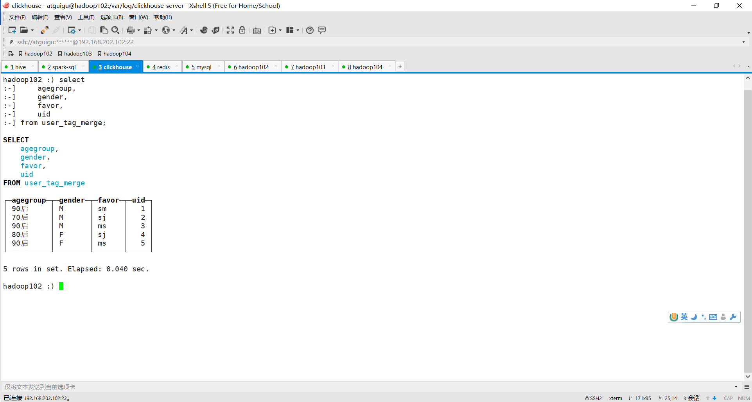

**2 ) Add the field name before each value and use parentheses to form a tuple.**

select

('agegroup', agegroup ),

('gender',gender ),

('favor',favor ),

uid

from user_tag_merge ;

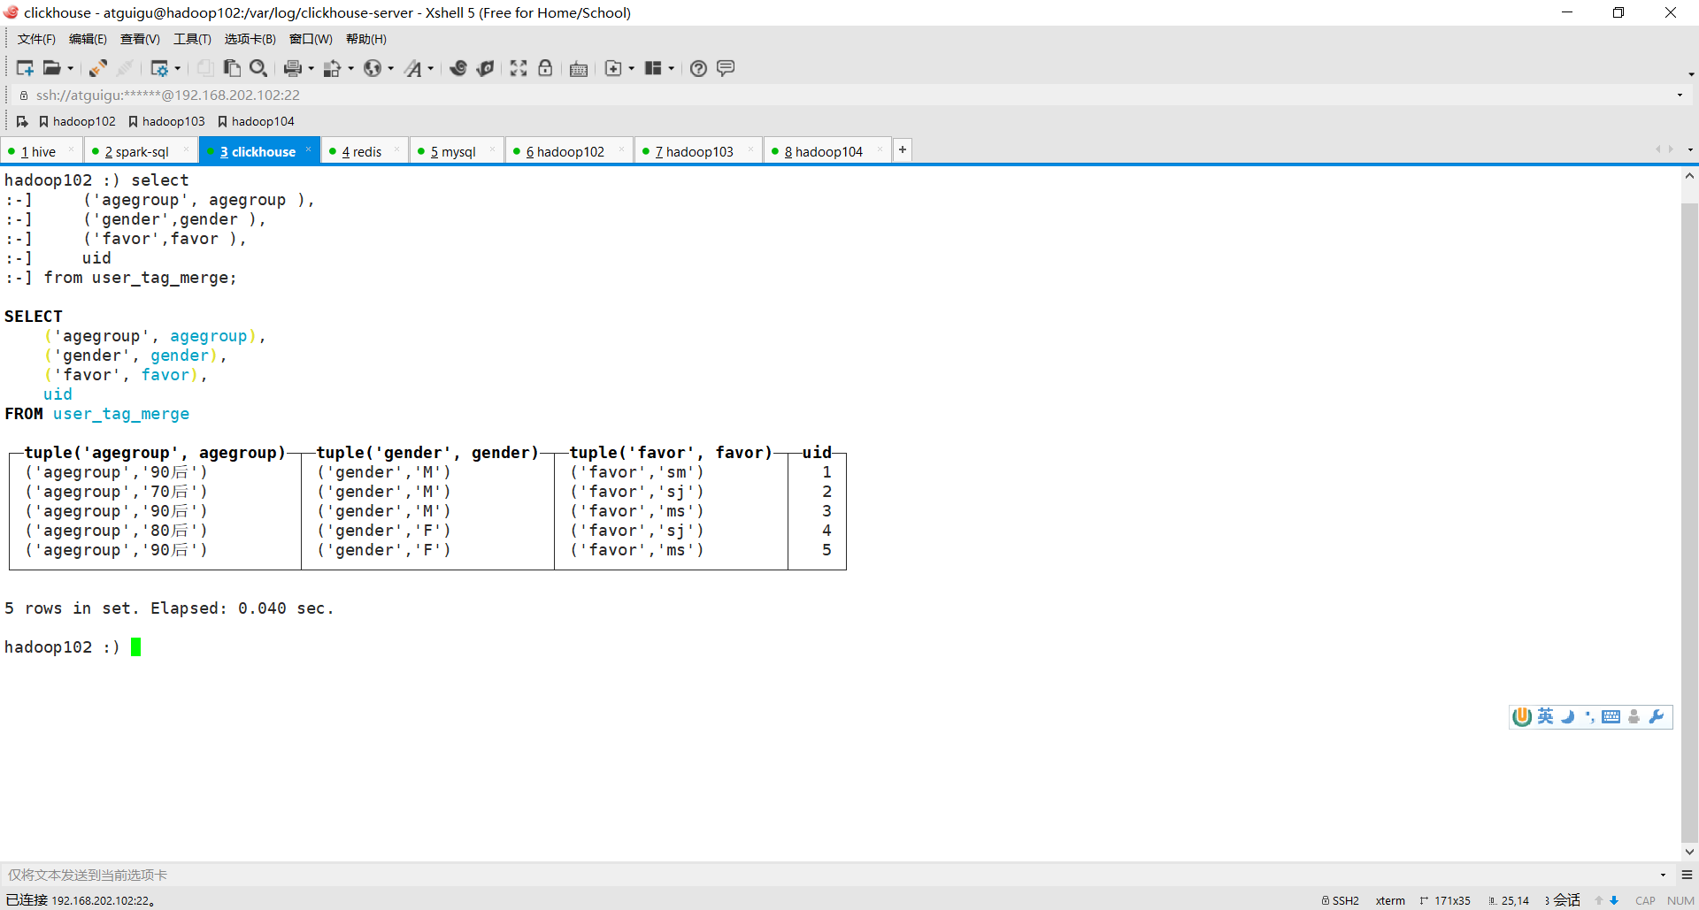

**3) Each column is concatenated into an array using [].**

select

[('agegroup', agegroup),

('gender',gender),

('favor',favor)] tag_code_value,

uid

from user_tag_merge;

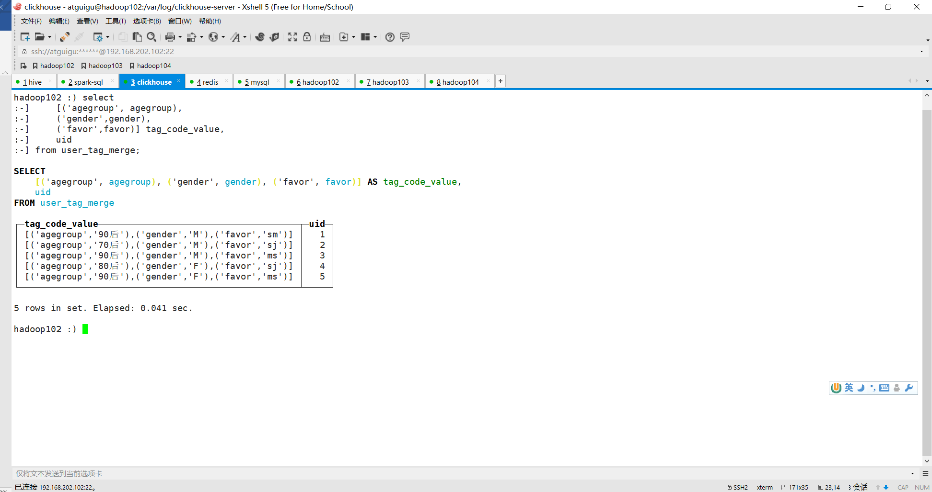

**4) Use arrayJoin to explode, similar to the explode in Hive**

SELECT

arrayJoin([('agegroup', agegroup), ('gender', gender), ('favor', favor)]) AS tag_code_value,

uid

FROM user_tag_merge ;

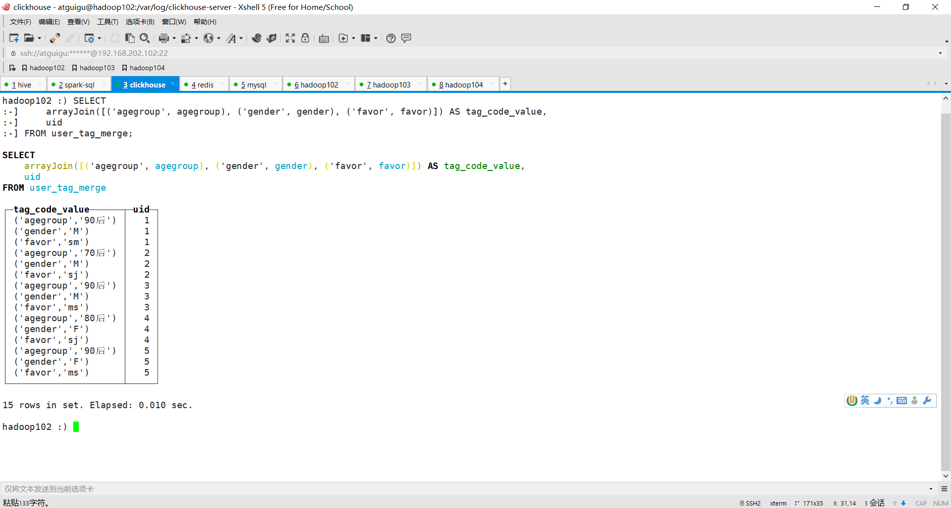

**5) Separate the field name and field value in the tuple and use these two as dimensions to aggregate_id**

SELECT

tag_code_value.1 AS tag_code,

tag_code_value.2 AS tag_value,

groupArray(uid) AS us

FROM (

SELECT

arrayJoin([('agegroup', agegroup), ('gender', gender), ('favor', favor)]) AS tag_code_value,

uid

FROM user_tag_merge

) AS tv

GROUP BY

tag_code_value.1,

tag_code_value.2 ;

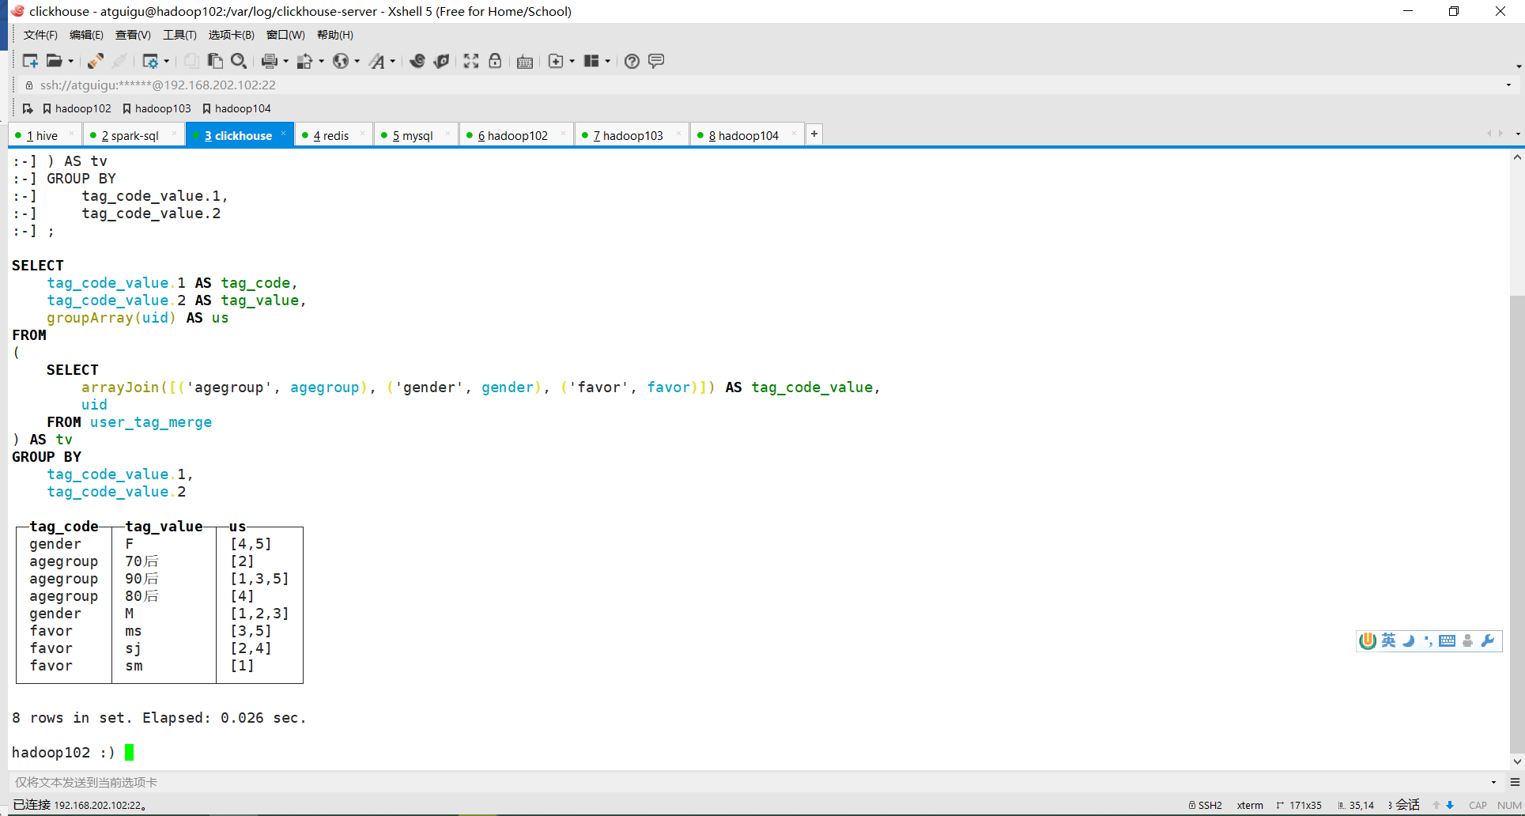

**6) Replace groupArray with groupBitmapState**

This is very close to the result we want. However, regarding the aggregation of user IDs , groupArray implements splicing into an array of user IDs , while what we want is to aggregate into a Bitmap .

Then just change the aggregation function.

SELECT

tag_code_value.1 AS tag_code,

tag_code_value.2 AS tag_value,

groupBitmapState (uid) AS us

FROM (

SELECT

arrayJoin([('agegroup', agegroup), ('gender', gender), ('favor', favor)]) AS tag_code_value,

uid

FROM user_tag_merge

) AS tv

GROUP BY

tag_code_value.1,

tag_code_value.2;

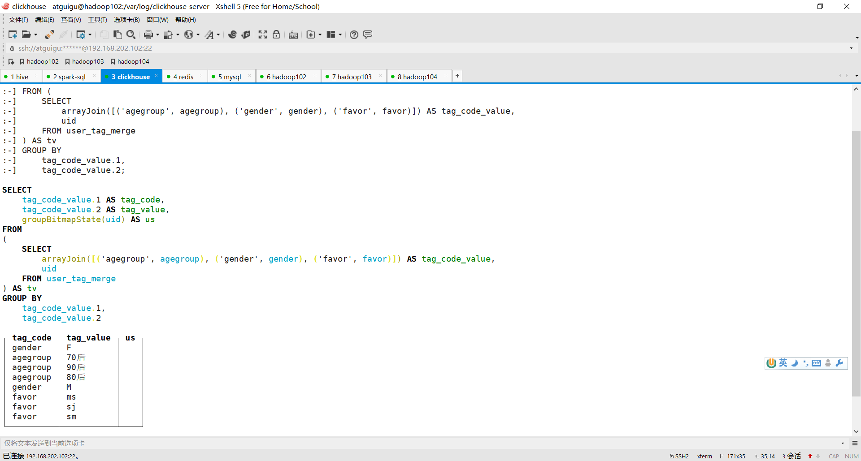

It is normal that the columns aggregated into bitmap are not displayed here, because the structure of bitmap itself cannot be displayed in normal text.

**7) Next we can insert into the bitmap table**

insert into user_tag_value_bitmap

select

tag_code_value.1 as tag_code,tag_code_value.2 as tag_value,

groupBitmapState( uid ) us

from (

SELECT

arrayJoin([('agegroup', agegroup), ('gender', gender), ('favor', favor)]) AS tag_code_value,

uid

FROM user_tag_merge

)tv

group by tag_code_value.1,tag_code_value.2 ;

**8) After the insertion is completed, the query still does not display normally**

select tag_code, tag_value , us from user_tag_value_bitmap ;

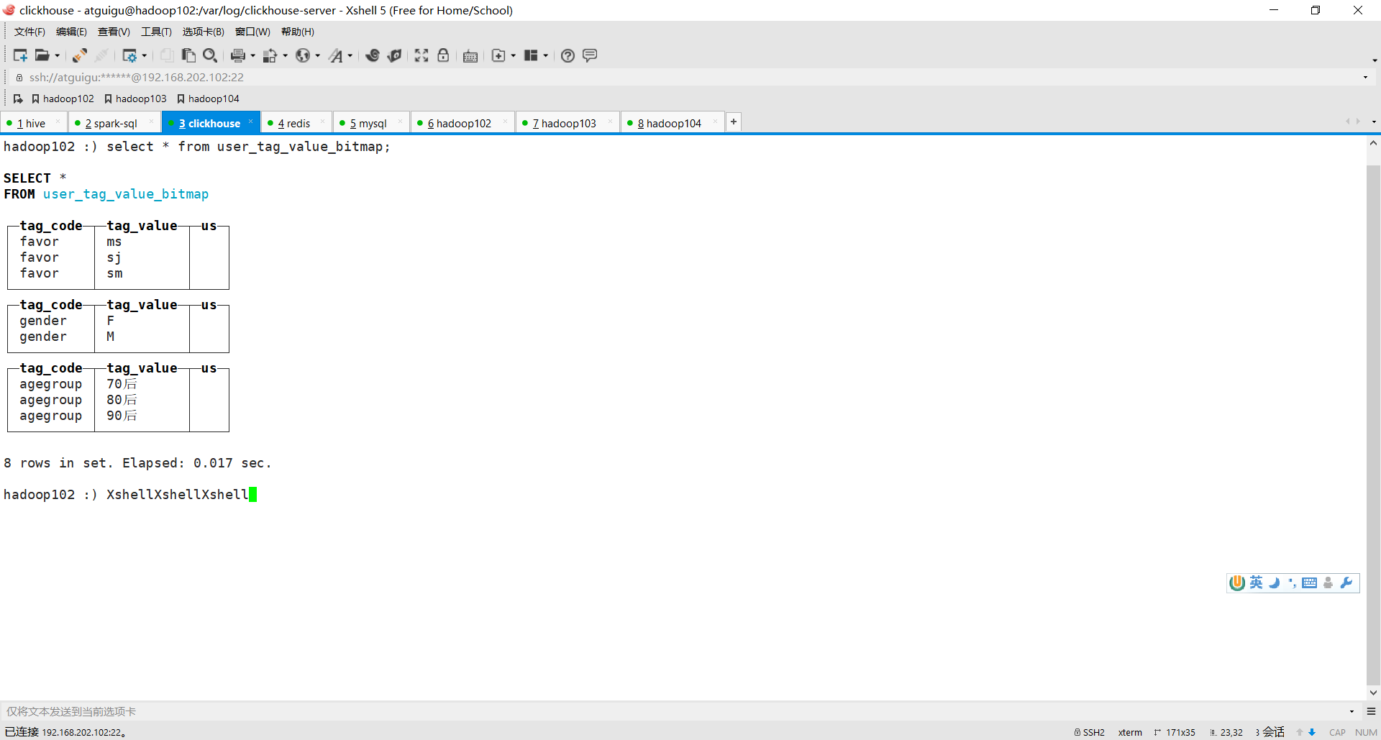

**9 ) can be verified by the bitmapToArray function**

select tag_code, tag_value ,bitmapToArray(us) from user_tag_value_bitmap;

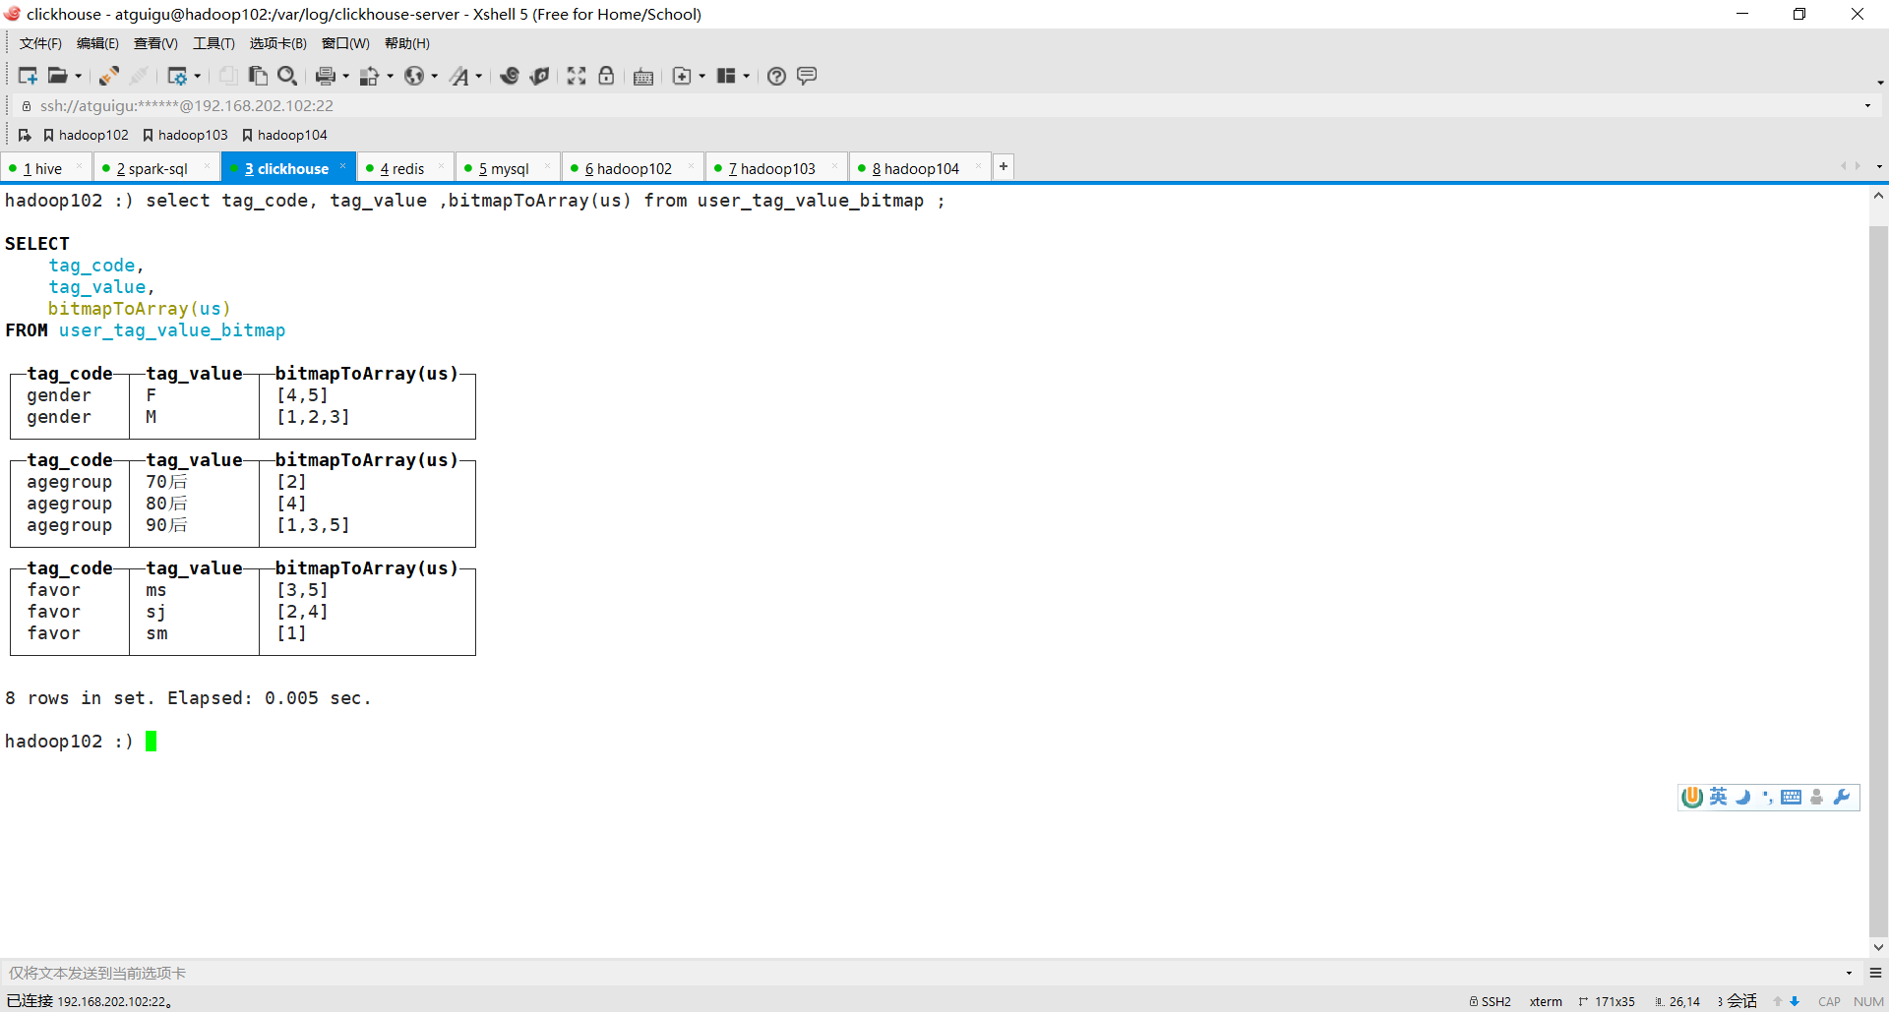

### 8.3.3 Querying Bitmap

How to use this B itmap table query?

8.3.3.1 Condition combination query

For example, I want to search for users who have [post-90s ] + [ food]

select

bitmapToArray(

bitmapAnd(

(select us from user_tag_value_ bitmap

where tag_value='ms' and tag_code='favor'),

(select us from user_tag_value_ bitmap

where tag_value='post-90s' and tag_code='agegroup')

)

)as res

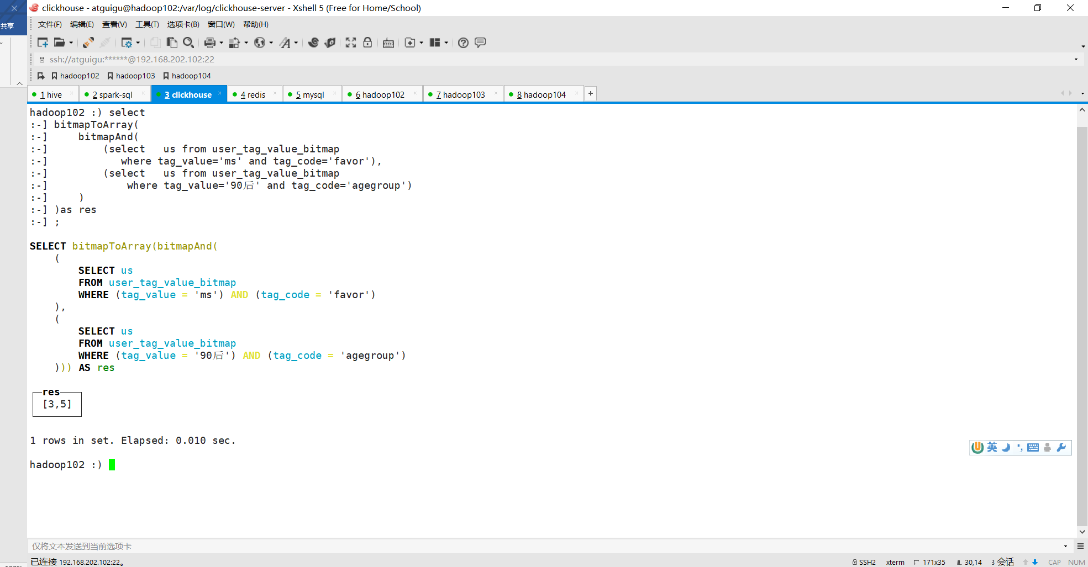

Here, we first use the condition to filter out the u s, each of which represents a set of u ids of a Bitmap structure , and then use the bitmapAnd function to find **the intersection of two** Bitmaps . Then, in order to observe the results, we use the bitmapToArray function to convert them into a visible array.

8.3.3.2 Range value query

For example, if you want to select [Post-90s ] or [ Post- 80s ] + [ Food]

select

bitmapToArray(

bitmapAnd(

(select groupBitmapMergeState(us) us from user_tag_value_ bitmap

where tag_value='ms' and tag_code='favor'),

(select groupBitmapMergeState(us) from user_tag_value_ bitmap

where tag_value in ('90s','80s') and tag_code='agegroup')

)

)as res

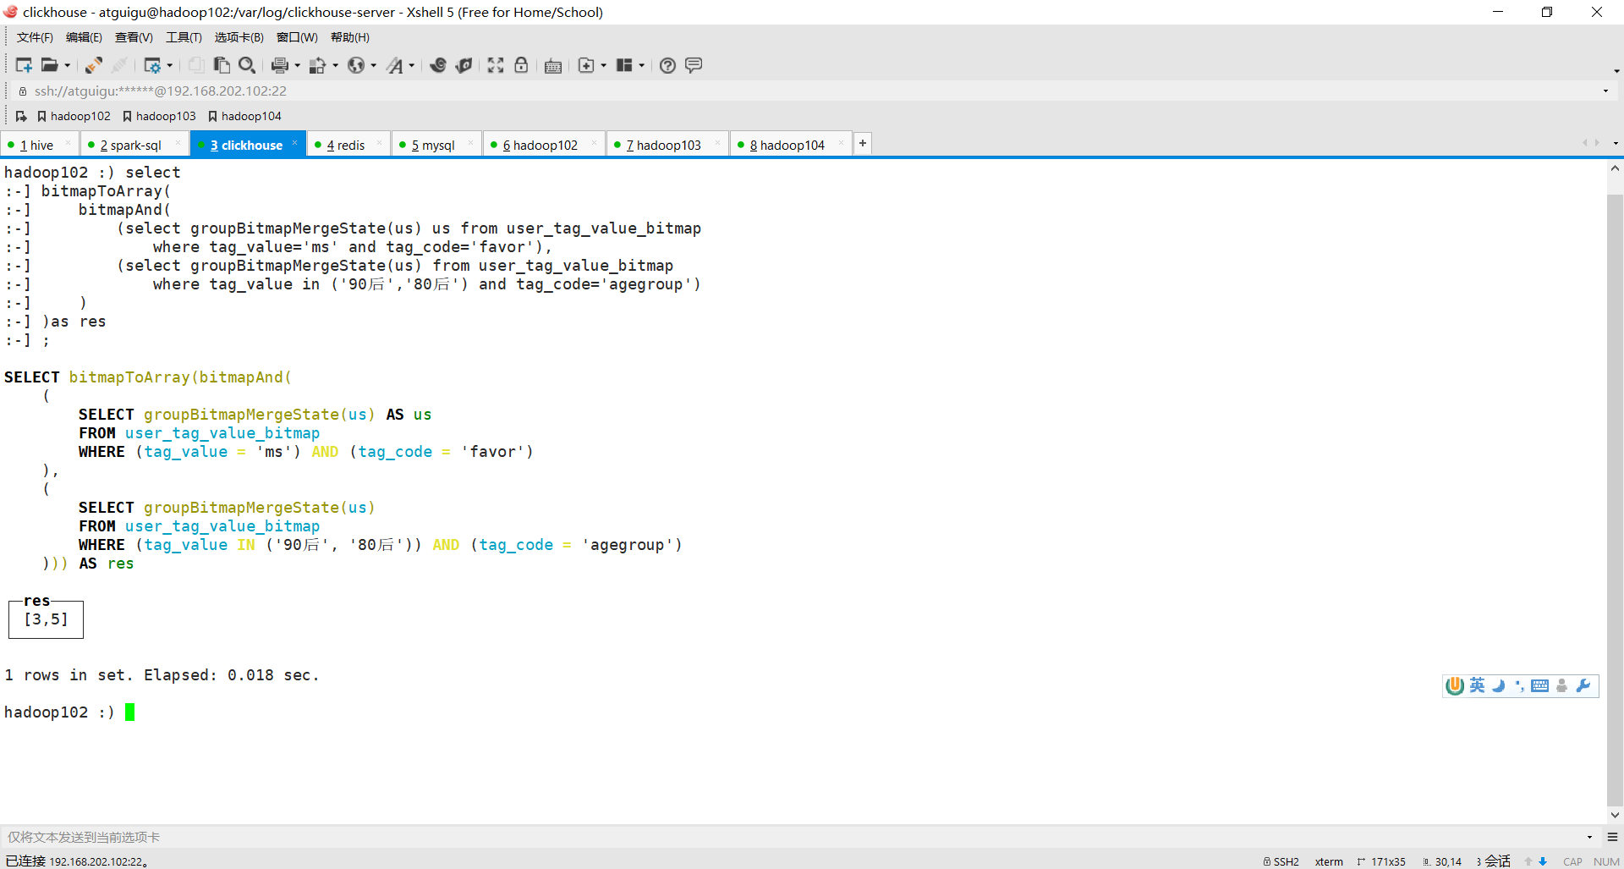

Because when querying, it may be necessary to take multiple values or even a range for a certain tag, which will involve multiple value userId sets . Therefore, it is necessary to use groupBitmapMergeState to merge once inside the subquery, which is actually the union of multiple sets.

### 8.3.4 Function Summary

|  |  |
| --- | --- |
| **Function** |  |
| **a rrayJoin** | Converting a wide table to a Bitmap table requires converting columns to rows. Use RayJoin to explode multi-column arrays into rows. |
| **groupBitmapState** | Aggregate the numeric values of the aggregate column into a Bitmap aggregation function |
| **bitmapAnd** | Find the intersection of two Bitmap values |
| **bitmap Or** | the union of two Bitmap values |
| **bitmap Xor** | the difference (XOR) of two Bitmap values |
| **bitmapToArray** | Bitmap to a numeric array |
| **groupBitmapMergeState** | Union and aggregate multiple Bitmap values in a column. (Continuous values) |
| **bitmapCardinality** | Find the number of values contained in Bitmap |

## 8.4 Mission Objectives

In order to perform conditional query on groups faster, the wide table in ClickHouse is transferred to the Bitmap table through **row-to-column and aggregation** operations.

## 8.5 Step Analysis

(1) Read the tag definition table to obtain the tag name and tag type.

(2) Create label value tables of four different data types.

(3) Depending on the tag type, it needs to be written into four different Bitmap tables .

## 8.6 Code Implementation

### 8.6.1 Add task -bitmap module

**1) Create a task -bitmap module under the user -profile-task project**

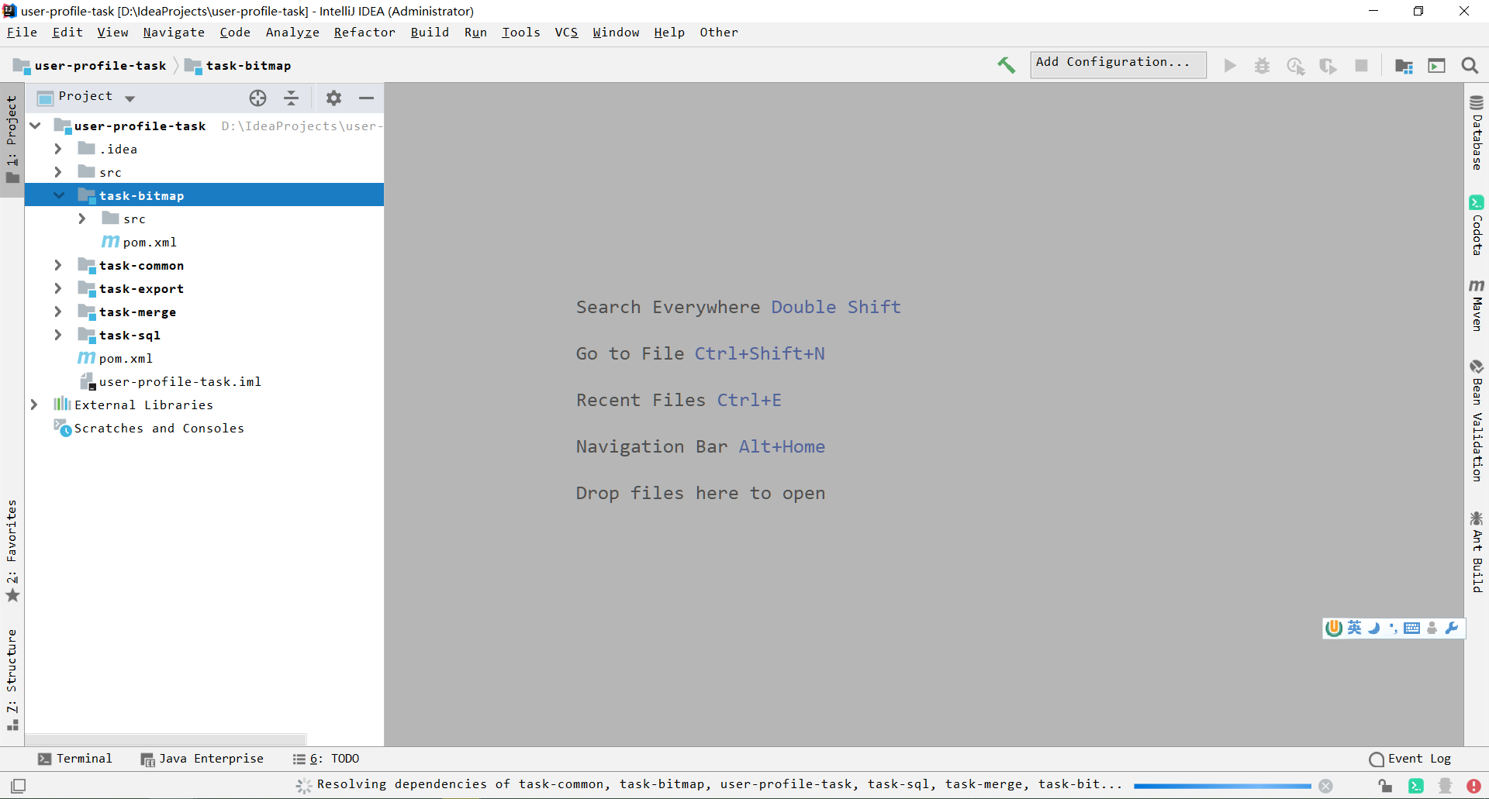

**2 ) Add common dependencies and** maven-assembly-plugin packaging plug-in in **pom.xml**

### 8.6.2 Establishing a database

create table user_tag_value_ string (

tag_code String,

tag_value String ,

us AggregateFunction(groupBitmap,UInt64),

dt String

)engine = AggregatingMergeTree()

partition by (dt, tag_code)

order by (tag_value);

create table user_tag_value_ long (

tag_code String,

tag_value UInt64 ,

us AggregateFunction(groupBitmap,UInt64),

dt String

)engine = AggregatingMergeTree()

partition by (dt, tag_code)

order by (tag_value);

create table user_tag_value_ decimal (

tag_code String,

tag_value Decimal64(2) ,

us AggregateFunction(groupBitmap,UInt64),

dt String

)engine = AggregatingMergeTree()

partition by (dt, tag_code)

order by (tag_value);

create table user_tag_value_ date (

tag_code String,

tag_value Date ,

us AggregateFunction(groupBitmap,UInt64),

dt String

)engine = AggregatingMergeTree()

partition by (dt, tag_code)

order by (tag_value);

### 8.6.4Main development task: Convert wide table to bitmap table

## 8.7 Debugging and running

**1 ) Configure execution parameters**

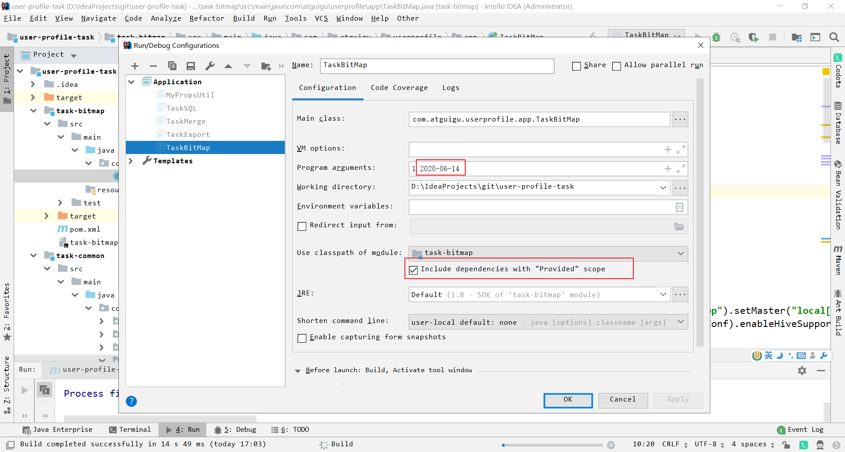

**2 ) View the results in ClickHouse**

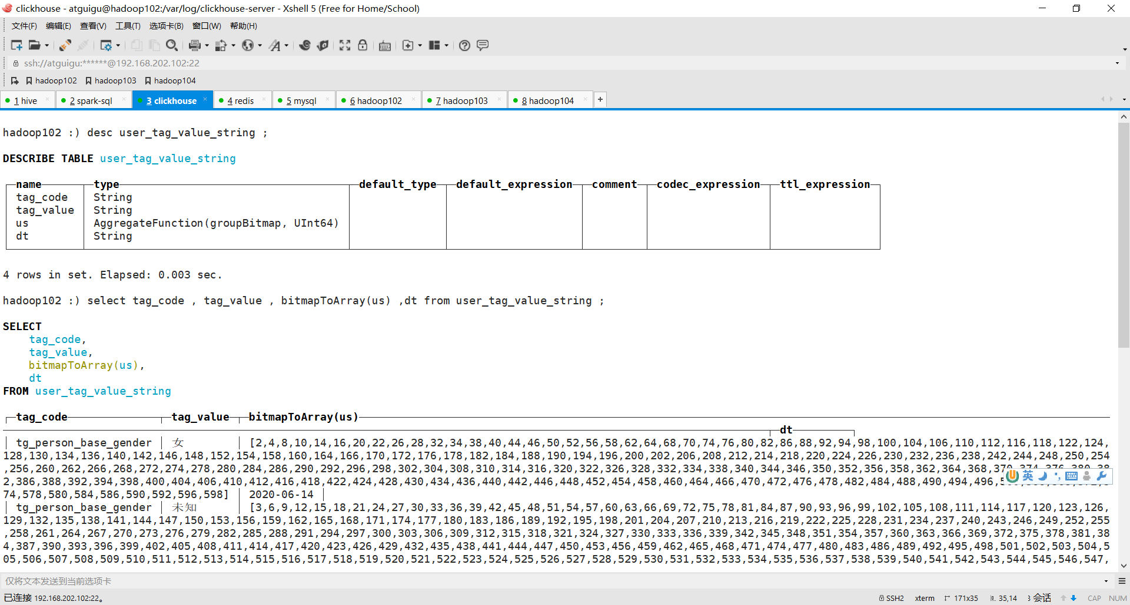

## 8.8Conversion Task Release - Functional Testing

### 8.8.1 Packaging

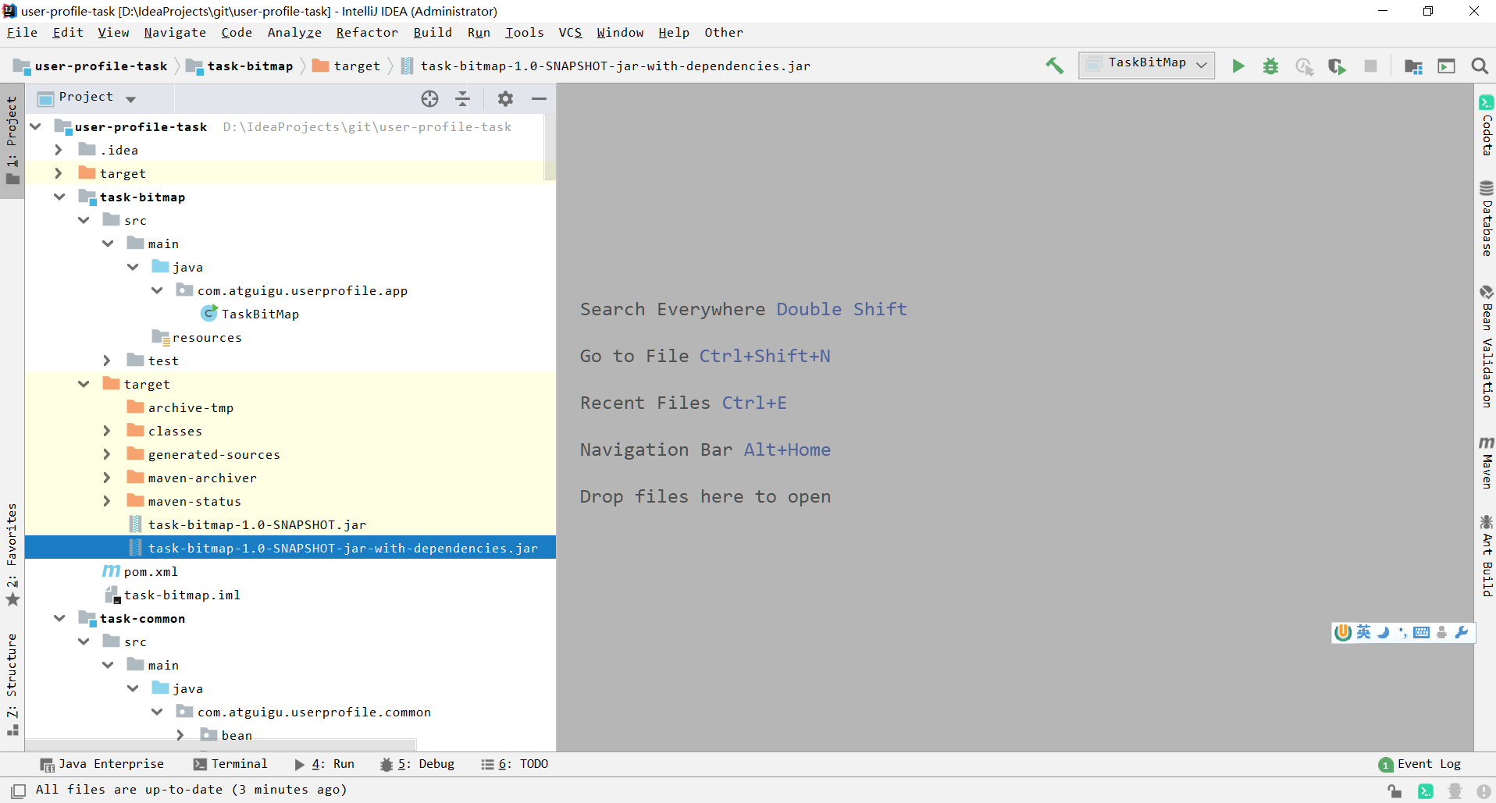

### 8.8.2 Click Add Process Task



### 8.8.3 Fill in the process tasks

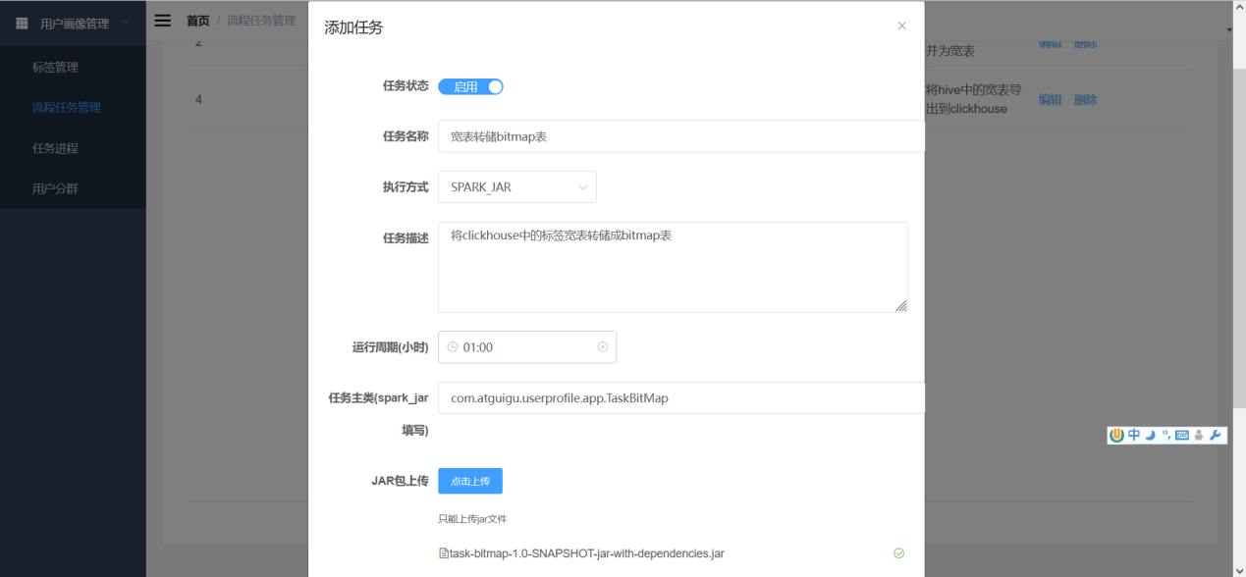

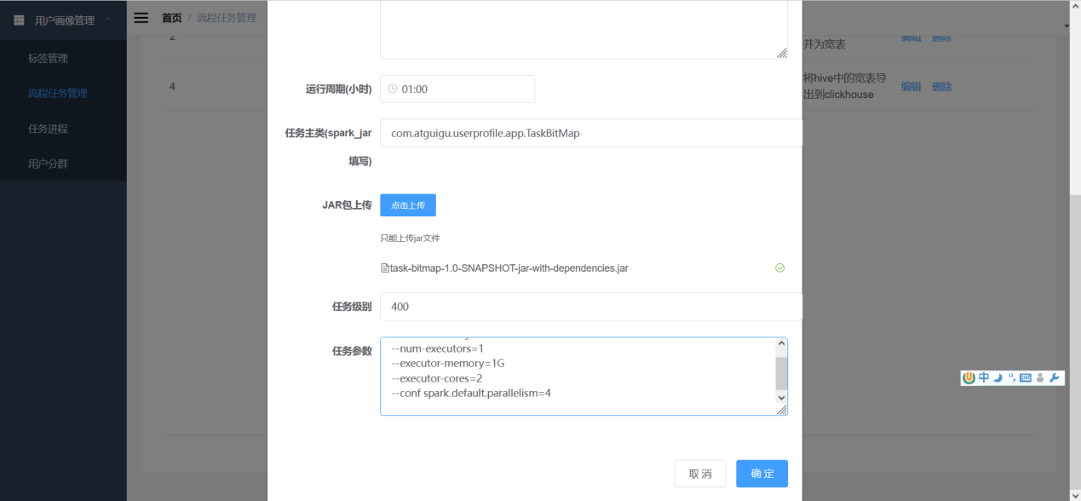

Because it is executed after the task of merging wide tables, the level is set to 400

### 8.8.3 Manually Scheduling Tasks

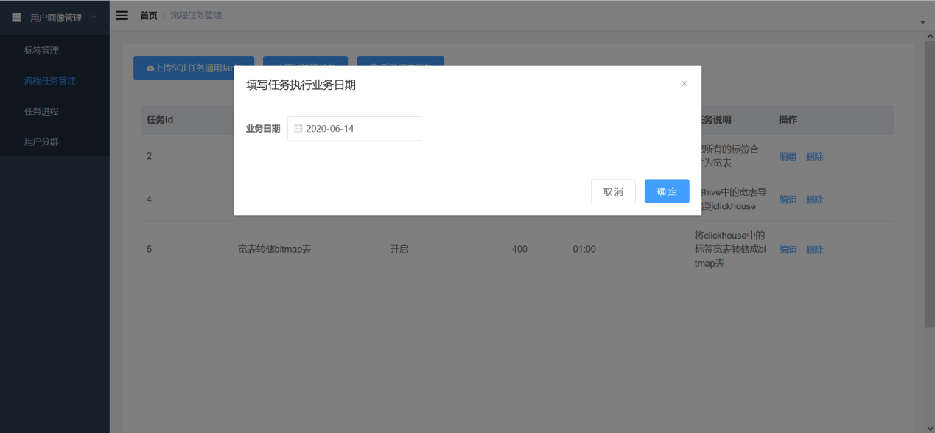

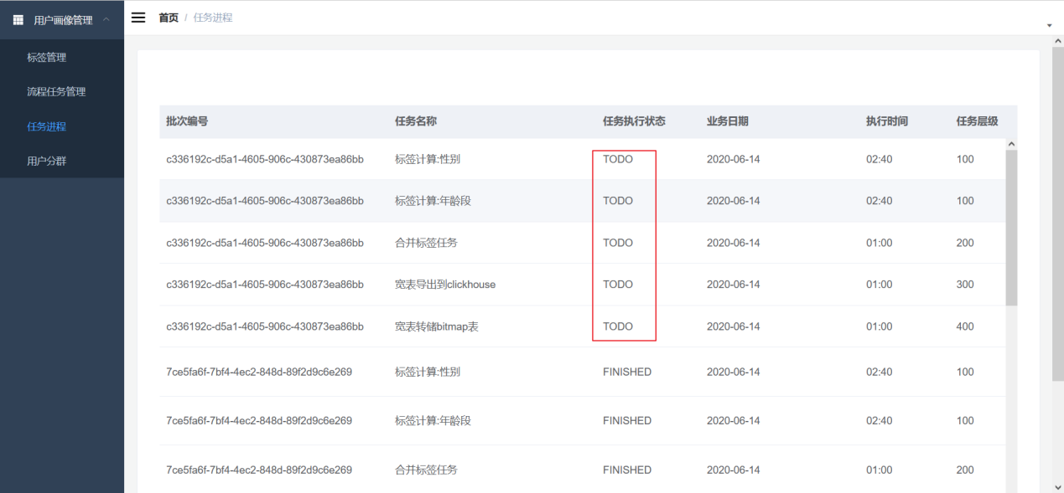

## 8.9 Verification results

**1) Make sure the status of each task is FINISHED**

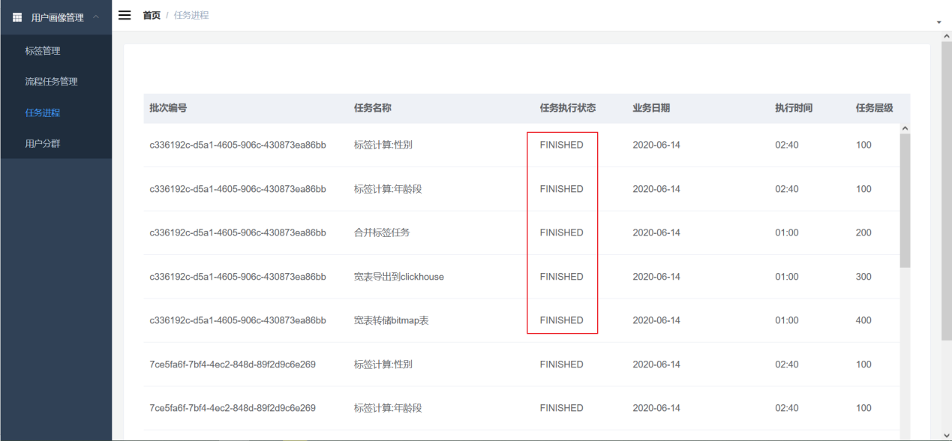

**2) View the exported wide table in ClickHouse**

SELECT

tag_code,

tag_value,

bitmapToArray(us)

FROM user_tag_value_string;

